**Data Dictionary**

**Survey of Non-Medical Use of Prescription Drugs Program (NMURx)**

**United States 19Q1 Launch**

**Dataset Name**

nmurx_us_19q1.sas7bdat

** Prior to 2019, the survey was desgined to be taken on a desktop computer. With the majority of respondents taking the survey on smartphones and tablets, they survey was redesigned to encorporate several design elements that include, but are not limited to the following:

* Responsive design formatting of questions compatible for smartphones and tablets, this means the visual format of the questions change to fit the screen appropriately
* Randomizing the order in which respondents see several questions and response options in order to reduce order effects
* Grouping of questions by drug class (pain relivers, sedatives, stimulants, and cannabinoids)
* Question reordering, rephrasing and revised introductory text

**Brief Overview**

The Survey of Non-Medical Use of Prescription Drugs (NMURx) Program employs an online survey of the general adult population to understand non-medical use (NMU) of prescription drugs. Volunteers from the general population are queried about NMU of prescription drugs. This program collects demographic information and whether the respondent is a student, healthcare professional, or current/former member of the armed forces, etc. The survey also solicits information on lifetime, last 12 months, last 90 day, last 30 day, and last 7 day NMU of prescription and over-the-counter drugs, including reason for NMU, frequency of NMU, route of administration, and source of drug acquisition. Questions regarding illicit drug use, chronic and acute pain, substance abuse treatment, and history of mental health disorders are also included. The Modified Drug Abuse Screening Test (DAST-10) is incorporated into the survey to evaluate the degree of consequences related to drug abuse. Quota sampling is used to provide a distribution of survey respondents that is proportional to census populations across geographic regions and similar proportions of males/females in each region. Surveys of 30,000 respondents are conducted semi-annually. Survey results are weighted to provide a national prevalence estimate of NMU of specific medications among the general population of adults. The US Survey of Non-Medical use of Prescription Drugs Program was initiated in 2016.

The dataset provided and described in this document is an abbreviated version of the entire survey. Product-level information and associated questions pertaining to last 12 month, last 90 day, last 30 day, and last 7 day use, including reason for NMU, frequency of NMU, route of administration, and source of drug acquisition have been removed (Questions B5-B15). Drug class variables for NMU in the last 12 month, last 90 day, last 30 day, and last 7 day use are included in Summary Variable section.

Notes:

The way the questions appear in this document do not necessarily reflect how respondents see the question on their screen. The general flow of the data dictionary navigations is as follows:

* Survey administration variables
* Demographics of respondent (i.e. age, gender, income, residence, etc.)- select questions are offered to the respondent first to establish inclusion criteria.
* Prescription Medication Questions (grouped by drug class)
  + Lifetime use
  + Last 12-month use
  + Last 12-month non-medical use (NMU)
  + Lifetime NMU
* End of Survey Questions- (i.e. other risk factors, illicit drug use, DAST-10 questionnaire, etc.)- here the remaining demographic and risk factor questions are asked.
* Summary Variables- derived variables from dataset to aid in analysis

Variable names that can be found in the data are in red along with the possible values they can hold. Purple text is explanatory text. Black text is largely question wording.

Question Numbering

Section | Question | Drug Class | API

Example: **B2.3.1**

|  |  |  |  |
| --- | --- | --- | --- |
| **B** | **2** | **3** | **1** |
| Prescription Drugs | 12-Month Use | Stimulant | Amphetamine |

**Overarching Survey Wide Variables**

**Vendor Variables**

|  |  |
| --- | --- |
| Date (character) | Completion time and date |
| Qtime (numeric) | Total interview time in seconds |
| start_date (character) | Date the survey was started |
| Status (numeric) | Respondent status where  Not Qualified….1 (invalid zip codes, age restrictions, confidentiality statement not signed, people who took the survey too fast)  Over Quota……2  Qualified……….3 (this data provided will be entirely qualified completed surveys, all entries will be this value)  Partial…………..4 |
| Vmobiledevice (numeric) | Device respondent took survey on  Smartphone………. 1  Feature phone …… 2  Tablet……………… 3  Other mobile………. 4  Desktop…………….. 5 |

<Added time stamp variables to capture how long the respondent spent on questions A2through A9>

|  |  |
| --- | --- |
| **Time spent on each question** | **Variable Name** |
| A1 | TIME_DEM1 |
| A2 | TIME_DEM2 |
| A3 | TIME_DEM3 |
| A4 | TIME_DEM4 |
| A5 | TIME_DEM5 |
| A6 | TIME_DEM6 |
| A7 | TIME_DEM7 |
| A8 | TIME_DEM8 |
| A9 | TIME_DEM9 |

<Added time stamp variables to capture how long the respondent spent on the lifetime use questions for the APIs>

|  |  |
| --- | --- |
| **Time spent on each question** | **Variable Name** |
| Pain Relievers | TIME_PAINREL |
| Sedatives | TIME_SED |
| Stimulants | TIME_STIM |
| Cannabinoids | TIME_THC |

## **Weighting**

WT Use this variable for all weighted analysis: represents the number of adults in the US that repsondents represents.

Calibration weighting were calculated using 2017 data for all (DEM_GENDER, DEM_AGE10, DEM_REGION, DEM_LIMIT, TOB_LIFE) variables in that order. Age was based on 10 year age categories, and the total weights add to the 2017 Residential Census Data for US adults ages 18+. Gender, age, region data came from the American Community Survey (2017) and limited acitivy and tobacco came from the National Health Interview Survey (2017).

Unweighted N = 29,873

Weighted N = 252,063,800

## **Randomization Variables**

Ex: If ORDER_PAINREL = 1, the respondent saw the pain relievers questions first.

|  |  |
| --- | --- |
| **Drug Class** | Variable Name (values 1-4) |
| Pain Relievers | ORDER_PAINREL |
| Sedatives | ORDER_SED |
| Stimulants | ORDER_STIM |
| Cannabinoids | ORDER_THC |

Note: The order the drug classes are initially presented in (for question B1, Lifetime Use) are randomized per respondent and maintained throughout the survey.

|  |  |
| --- | --- |
| **Pain Reliever APIs** | **Variable Name** (values 1-17) |
| Benzhydrocodone | ORDER_PAINREL_API_BHYD |
| Buprenorphine | ORDER_PAINREL_API_BUP |
| Codeine | ORDER_PAINREL_API_COD |
| Dihydrocodeine | ORDER_PAINREL_API_DIHY |
| Eluxadoline | ORDER_PAINREL_API_ELU |
| Fentanyl | ORDER_PAINREL_API_FENT |
| Gabapentin | ORDER_PAINREL_API_GAB |
| Hydrocodone | ORDER_PAINREL_API_HYD |
| Hydromorphone | ORDER_PAINREL_API_HYDM |
| Ketamine | ORDER_PAINREL_API_KTM |
| Methadone | ORDER_PAINREL_API_METH |
| Morphine | ORDER_PAINREL_API_MORPH |
| Oxycodone | ORDER_PAINREL_API_OXY |
| Oxymorphone | ORDER_PAINREL_API_OXYM |
| Pregabalin | ORDER_PAINREL_API_PREG |
| Sufentanil | ORDER_PAINREL_API_SUF |
| Tapentadol | ORDER_PAINREL_API_TAP |
| Tramadol | ORDER_PAINREL_API_TRAM |

Note: The order the Pain Relievers are initially presented in (as response options in question B1.1, Lifetime Use) were randomized per respondent and maintained throughout the survey. Example: If Methadone is shown first for question B1.1, it was first API shown for question B2.

|  |  |
| --- | --- |
| **Sedative APIs** | **Variable Name** (values 1-18) |
| Alprazolam | ORDER_SED_API_ALP |
| Baclofen | ORDER_SED_API_BAC |
| Chlordiazepoxide | ORDER_SED_API_CHL |
| Clobazam | ORDER_SED_API_CLOB |
| Clonazepam | ORDER_SED_API_CLON |
| Clorazepate | ORDER_SED_API_CLOR |
| Diazepam | ORDER_SED_API_DIA |
| Estazolam | ORDER_SED_API_EST |
| Eszopiclone | ORDER_SED_API_ESZ |
| Flurazepam | ORDER_SED_API_FLUR |
| Lorazepam | ORDER_SED_API_LORA |
| Midazolam | ORDER_SED_API_MID |
| Oxazepam | ORDER_SED_API_OXA |
| Quazepam | ORDER_SED_API_QUA |
| Temazepam | ORDER_SED_API_TEM |
| Triazolam | ORDER_SED_API_TRI |
| Zaleplon | ORDER_SED_API_ZAL |
| Zolpidem | ORDER_SED_API_ZOL |

Note: The order the Sedative APIs are initially presented in (as response options in question B1.2, Lifetime Use) were randomized per respondent and maintained throughout the survey.

|  |  |
| --- | --- |
| **Stimulant APIs** | **Variable Name** (values 1-4) |
| Amphetamine | ORDER_STIM_API_AMPH |
| Atomoxetine | ORDER_STIM_API_ATOM |
| Methylphenidate | ORDER_STIM_API_MPHEN |
| Modafinil | ORDER_STIM_API_MOD |

Note: The order the Stimulant APIs are initially presented in (as response options in question B1.3, Lifetime Use) were randomized per respondent and maintained throughout the survey.

|  |  |
| --- | --- |
| **Cannabinoid APIs** | **Variable Name** (values 1-3) |
| Cannabidiol | ORDER_THC_API_CANN |
| Dronabinol | ORDER_THC_API_DRON |
| Nabilone | ORDER_THC_API_NAB |

Note: The order the Cannabinoid APIs are initially presented in (as response options in question B1.4, Lifetime Use) were randomized per respondent and maintained throughout the survey.

|  |  |
| --- | --- |
| **Non-Prescription APIs** | **Variable Name** (values 1-8) |
| Acetaminophen | ORDER_OTC_API_ACE |
| Aspirin | ORDER_OTC_API_ASP |
| Dextromethorphan | ORDER_OTC_API_DEX |
| Diphenhydramine | ORDER_OTC_API_DIPH |
| Ibuprofen | ORDER_OTC_API_IBU |
| Loperamide | ORDER_OTC_API_LOP |
| Naproxen | ORDER_OTC_API_NAP |
| Other or unknown  (always appears last) | ORDER_OTC_API_OTCOTH  (should always take the value of 8) |

Note: The order the Non-Prescription APIs are initially presented in (as response options in question C.1) were randomized per respondent and maintained throughout the survey.

|  |  |
| --- | --- |
| **Illicit Drugs** | **Variable Name** (Values 1-19) |
| Cocaine Powder | ORDER_ILLICIT_API_COKE |
| Crack Cocaine | ORDER_ILLICIT_API_CRACK |
| MDMA | ORDER_ILLICIT_API_MDMA |
| GHB/GBL | ORDER_ILLICIT_API_GHB |
| Alkyl Nitrites or Nitrous | ORDER_ILLICIT_API_ALKY |
| Kratom | ORDER_ILLICIT_API_KRAT |
| Non-pharmaceutical amphetamine | ORDER_ILLICIT_API_SPEED |
| Methamphetamine | ORDER_ILLICIT_API_METHAM |
| Non-pharmaceutical fentanyl | ORDER_ILLICIT_API_NPFENT |
| Heroin | ORDER_ILLICIT_API_HEROIN |
| Ketamine | ORDER_ILLICIT_API_KET |
| Mephedrone | ORDER_ILLICIT_API_MEPH |
| LSD | ORDER_ILLICIT_API_LSD |
| Psilocybin or mushrooms | ORDER_ILLICIT_API_MUSH |
| PCP or phencyclidine | ORDER_ILLICIT_API_PCP |
| Mescaline | ORDER_ILLICIT_API_MESC |
| Synthetic cannabinoid receptor agonists | ORDER_ILLICIT_API_SPICE |
| Salvia | ORDER_ILLICIT_API_SAL |
| Anabolic steroids not prescribed by a healthcare professional | ORDER_ILLICIT_API_STER |

Note: The order the Illicit Drugs are initially presented in (as response options in question D9) were randomized per respondent and maintained throughout the survey.

# Proprietary Statement

Data from the RADARS® System Survey of Non-Medical Use of Prescription Drugs Program are **not public**. These data are **proprietary** and are only to be used for the purposes of the American Statistical Association’s DataFest. By using this data, you agree to:

1. During participation in DataFest, **store** and **manage** the data securely and **privately**.
2. **Erase all data** after your DataFest participation is complete.
3. **Not identify or attempt to identify** the information contained in the dataset, **nor contact** any of the individuals whose information is contained in the dataset.
4. **Comply with** all applicable U.S. federal and state laws and regulations relating to the maintenance of the dataset, the safeguarding of the confidentiality of the dataset, and the use and disclosure of the dataset.
5. **Not publish** results of your analysis of the data except that the final products of the competition (video, slide deck, one-page summary) may be displayed on team members' websites and on campus DataFest websites.
6. **Not share** the data with anyone who is not a participant of DataFest.

~ ~ ~ BEGINNING OF QUESTIONNAIRE ~ ~ ~

# Language & Implied Consent

A1a. Please select in which language you would like to take the survey QLANG

English…………………………………….1

Spanish…………………………………….2

<Skip Logic> If respondent selects “English”, continue in English. If respondent selects “Spanish”, continue in Spanish.

<Responsive Design> See Appendix 1.1 Radio Button

This year, we are surveying about 60,000 people across the country. You are asked to take part in this research study. You will represent other people in the United States who are similar to you. This study asks about your use of medications, tobacco, alcohol, drugs, and other health issues. Your answers about these topics are important. Policymakers and researchers can use information from this study to understand drug addiction and treatment needs in the United States. This survey should take about 10 to 15 minutes to complete.

Taking this survey is voluntary. You do not have to take the survey. If you start to take the survey and change your mind, you may stop. We will only use information you choose to enter into the survey before stopping. There will not be any penalty for not taking the survey or for stopping the survey. You will be paid according to your panel’s policy. We ask that you try to answer all questions. Some questions and sections are designed so that you do not have to answer.

Your answers will be completely confidential and are anonymous to the researchers. The researchers will not receive any information that can identify you. The survey panel that gives this survey will link a code to you so that the researchers can note if you have taken more than one survey. However, the researchers will never be able to identify you with this code.

This research is covered by a Certificate of Confidentiality from the National Institutes of Health. The researchers with this Certificate may not disclose or use information or documents that may identify you in any federal, state, or local civil, criminal, administrative, legislative, or other action, suit, or proceeding, or be used as evidence, for example, if there is a court subpoena, unless you have consented for this use. Information protected by this Certificate cannot be disclosed to anyone else who is not connected with the research except if it is required by federal, state, or local laws, or used for other scientific research, as allowed by federal regulations protecting research subjects. You should understand that a Certificate of Confidentiality does not prevent you from voluntarily releasing information or documents about yourself or your involvement in this research. These protections apply only to your research records.

RADARS® System, a division of Denver Health and Hospital Authority, conducts this study. For questions or concerns, you may call the research team at (303) 389-1610. For questions about your rights as a research participant, you may call the Colorado Multiple IRB at (303) 724-1055.

A1. I was provided with information about the survey and I was told that information I provide will be kept private. I choose to take the survey.

Yes

No

<Skip Logic> If respondent selects “No”, exit the survey.

<Responsive Design> See Appendix 1.1 Radio Button

# Demographics

A2. What is your sex? DEM_GENDER

Male………………………..1

Female ……………………2

<Skip Logic> If DEM_GENDER = 1, do not show question D26 or D27.

<Responsive Design> See Appendix 1.1 Radio Button

A3. What is your age in years? DEM_AGE (Numeric: Value field- minimum age 18 and maximum age 110)

<Skip Logic> If DEM_AGE <18 or > 110, exit the survey.

<Responsive Design> See Appendix 1.11: OE Numeric Field

<Derived variables not chosen by respondent>

10-year age categories- made variable DEM_AGE10

18-24 years………………………1

25-34 years………………………2

35-44 years………………………3

45-54 years………………………4

55-64 years………………………5

65+ years…………………………6

A4. Please indicate the first three digits of the five digit ZIP code that you currently live in. DEM_POSTAL (character: 3 digits. HIPPA restricted ZIP codes were recoded to 000.)

<Responsive Design> See Appendix 1.11 OE Numeric Field>

<Derived variables not chosen by respondent>

First three digits of the ZIP code that you currently live in. DEM_ZIP (numeric version of postal code. HIPPA restricted ZIP codes were recoded to 0.)

<Derived variables not chosen by respondent>

State currently live in. DEM_STATE (character: 2 letter state abbreviation. Created based on postal code provided)

<Derived variables not chosen by respondent>

Region currently live in. DEM_REGION (created based on state with the regions listed in the table below)

Northeast 1

Midwest 2

South 3

West 4

Region Mapping List

|  |  |
| --- | --- |
| **State List** | **Region** |
| [DEM_STATE] = CT, ME, MA, NH, RI, VT, NJ, NY, PA | Northeast [DEM_REGION = 1] |
| [DEM_STATE] = IL, IN, MI, OH, WI, IA, KS, MN, MO, NE, ND, SD | Midwest [DEM_REGION = 2] |
| [DEM_STATE] = DE, DC, FL, GA, MD, NC, SC, VA, WV, AL, KY, MS, TN, AR, LA, OK, TX | South [DEM_REGION = 3] |
| [DEM_STATE] = AZ, CO, ID, MT, NV, NM, UT, WY, AK, CA, OR, WA, HI | West [DEM_REGION = 4] |

A5. What was your combined household income during the last 12 months? DEM_INCOME

Less than $25,000……………………………….1

Between $25,000 and $49,999…………………2

Between $50,000 and $74,999…………………3

Between $75,000 and $99,999…......................4

$100,000 or more………………………………...5

A6. How many people are living or staying at your home including yourself and anyone who has nowhere else to stay? Please do not include anyone living somewhere else, such as a college student or armed forces member on deployment.

DEM_HOME

<Responsive Design> See Appendix 1.11: OE Numeric Field

A7. Would you say your health in general is excellent, very good, good, fair, or poor? DEM_GENHEALTH

Poor…………………………….……..1

Fair………………………………….…2

Good……………………………….….3

Very good…………………………….4

Excellent………………………………5

<Responsive Design> See Appendix 1.10: Single Slider

A8. Are you currently limited in your usual activities in any way due to a medical condition? DEM_LIMIT

Yes……………………………………..1

No………………………………………0

<Responsive Design> See Appendix 1.1 Radio Button

A9. Do you NOW smoke cigarettes every day, some days, or not at all? Please answer "Not at all" if you have smoked fewer than 100 cigarettes in your life. TOB_LIFE

Every day……………………………….1

Some days……………………………...2

Not at all…………………………………3

Don’t know………………………………4

<Responsive Design> See Appendix 1.1 Radio Button

# Prescription Medication

## Lifetime Use

Next, we will ask you about your use of four types of prescription medications: pain relievers, sedatives, stimulants, and cannabinoids.

<Programming> Question B1.1 (Pain Relievers), B1.2 (Sedatives), B1.3 (Stimulants) and B1.4 (Cannabinoids) will be randomly presented to participants. The order in which the drug groups are presented in this section will be preserved throughout the remainder of the questionnaire. For example, if the order for Lifetime Use is B1.3, B1.1, B1.4, B1.2, then the order for 12-Month Use should be B2.3, B2.1, B2.4, B2.2. Blue text below indicates drug classification used in drug summary variables.

The question below is about prescription pain relievers. These medications are used to treat pain and can cause a happy, relaxed feeling.

Some pain relievers are available without a prescription or are made illegally (not by a drug company). We will ask you about these types of pain relievers later in the survey.

B1.1. Have you ever used the prescription **pain reliever** below?

Yes……………………………………..1

No………………………………………0

|  |  |
| --- | --- |
| **Pain Reliever** | **Variable Name** |
| **Benzhydrocodone** such as Apadaz®  opioid | BHYD_USE |
| **Buprenorphine** such as Belbuca®, Bunavil®, Butrans®, Buprenex®, Probuphine®, Sublocade® ER, Suboxone®, Subutex®, Zubsolv®, or other generics  opioid | BUP_USE |
| **Codeine** such as Fioricet® with codeine, Fiorinal® with codeine, Triacin-C, Tuzistra® XR, Tylenol® with codeine No. 3 or 4, or other generics\  opioid | COD_USE |
| **Dihydrocodeine** such as Trezix™ or other generics  opioid | DIHY_USE |
| **Eluxadoline** such as Viberzi®  opioid antagonist- not included in any opioid rollup | ELU_USE |
| **Fentanyl** such as Abstral®, Actiq®, Duragesic®, Fentora®, Lazanda®, Subsys®, or other generics  opioid | FENT_USE |
| **Gabapentin** such as Gralise®, Horizant®, Neurontin®, or other generics  gaba-analogue | GAB_USE |
| **Hydrocodone** such as Anexsia, Flowtuss™, Hycofenic®, Hysingla® ER, Norco®, ObredonTM, Reprexain™, Rezira®, TussiCaps®, Tussigon®, Vicodin®, Vituz®, Zohydro® ER, Zutripro®, or other generics  opioid | HYD_USE |
| **Hydromorphone** such as Dilaudid®, Dilaudid-HP®, Exalgo®, or other generics  opioid | HYDM_USE |
| **Ketamine** such as Ketalar® or other generics  anesthetic | KTM_USE |
| **Methadone** such as Dolophine®, Methadose™, or other generics  opioid | METH_USE |
| **Morphine** such as Apokyn®, Arymo™ ER, Astramorph PF™, Duramorph PF, Embeda®, Infumorph, Kadian®, MitigoTM, Morphabond™ ER, MS Contin®, or other generics  opioid | MORPH_USE |
| **Oxycodone** such as Oxaydo®, Oxecta®, Oxycet®, Oxycontin®, Percocdet®, Percodan®, Roxicodone®, Roxicet™, Roxybond™, Xtampza® ER, or other generics  opioid | OXY_USE |
| **Oxymorphone** such as Opana®, Opana® ER, or other generics  opioid | OXYM_USE |
| **Pregabalin** such as Lyrica® or Lyrica® CR  gaba-analogue | PREG_USE |
| **Sufentanil** such as Dsuvia®, Sufenta®, Zalviso®, or other generics  opioid | SUF_USE |
| **Tapentadol** such as Nucynta® or Nucynta® ER  opioid | TAP_USE |
| **Tramadol** such as ConZip™, Ultram®, Ultracet®, or other generics  opioid | TRAM_USE |

<Skip Logic> If the respondent selects “No” to each pain reliever, do not display questions B2.1-B4.1. Only display pain relievers that were selected in the question above in B2.1.

<Responsive Design> See Appendix 1.4: Lifetime Use & NMU

The question below is about prescription sedatives and anti-anxiety medications. These medications are used to treat insomnia or trouble sleeping, anxiety, panic disorders, and seizures (convulsions).

Some sedatives are available without a prescription or are made illegally (not by a drug company). We will ask you about these types of sedatives later in the survey.

B1.2. Have you ever used the prescription **sedative** below?

Yes……………………………………..1

No………………………………………0

|  |  |
| --- | --- |
| **Sedatives** | **Variable Name** |
| **Alprazolam** such as Niravam®, Xanax®, Xanax XR®, or other generics | ALP_USE |
| **Baclofen** such as Gablofen®, Lioresal®, or other generics  gaba-analogue | BAC_USE |
| **Chlordiazepoxide** such as Librax®, Librium®, or other generics | CHL_USE |
| **Clobazam** such as ONFI® or other generics | CLOB_USE |
| **Clonazepam** such as Klonopin® or other generics | CLON_USE |
| **Clorazepate** such as Gen-xene®, Tranxene®, or other generics | CLOR_USE |
| **Diazepam** such as Diastat®, Diastat® AcuDial™, Valium®, or other generics | DIA_USE |
| **Estazolam** such as generics | EST_USE |
| **Eszopiclone** such as Lunesta® or other generics  z-drug | ESZ_USE |
| **Flurazepam** such as generics | FLUR_USE |
| **Lorazepam** such as Ativan® or other generics | LORA_USE |
| **Midazolam** such as generics | MID_USE |
| **Oxazepam** such as generics | OXA_USE |
| **Quazepam** such as Doral® or other generics | QUA_USE |
| **Temazepam** such as Restoril™ or other generics | TEM_USE |
| **Triazolam** such as Halcion® or other generics | TRI_USE |
| **Zaleplon** such as Sonata® or other generics  z-drug | ZAL_USE |
| **Zolpidem** such as Ambien®, Ambien CR®, Edluar™, Intermezzo®, Zolpimist®, or other generics  z-drug | ZOL_USE |

<Skip Logic> If the respondent selects “No” for each sedative, do not display questions B2.2-B4.2. Only display sedatives that were selected in the question above in question B2.2.

<Responsive Design> See Appendix 1.4: Lifetime Use & NMU

The question below is about stimulants and attention deficit hyperactivity disorder (ADHD) medications. These medications are used to treat ADHD or narcolepsy. They are also known to aid with losing weight, staying awake, or studying.

Some stimulants are available without a prescription or are made illegally (not by a drug company). We will ask you about these types of stimulants later in the survey.

B1.3. Have you ever used the prescription **stimulant** below?

Yes……………………………………..1

No………………………………………0

|  |  |
| --- | --- |
| **Stimulants** | **Variable Name** |
| **Amphetamine** such as Adderall®, Adderall XR®, Adzenys ER™, Adzenys XR-ODT™, Desoxyn®, Dexedrine®, Dyanavel® XR, Evekeo®, Mydayis®, Paremyd®, Vyvanse®, or other generics | AMPH_USE |
| **Atomoxetine** such as Strattera® or other generics | ATOM_USE |
| **Methylphenidate** such as Aptensio XR®, Concerta®, Cotempla XR-ODT, Daytrana®, Focalin®, Focalin XR®, Metadate CD®, Metadate® ER, Methylin™ ER, Quillichew ER™, Quillivant XR®, Ritalin LA®, Ritalin SR®, or other generics | MPHEN_USE |
| **Modafinil** such as Nuvigil®, Provigil®, or other generics | MOD_USE |

<Skip Logic> If the respondent selects “No” for each stimulant, do not display questions B2.3 – B4.3. Only display stimulants that were selected in the question above in question B2.3.

<Responsive Design> See Appendix 1.4: Lifetime Use & NMU

The question below is about prescription cannabinoids and THC made by drug companies. These medications are used to treat nausea and to increase appetite.

Some cannabinoids are available without a prescription or are not made by drug companies, such as medical, recreational, or illegal cannabis or marijuana. We will ask you about these types of cannabis later in the survey.

B1.4. Have you ever used the prescription **cannabinoid** below?

Yes……………………………………..1

No………………………………………0

|  |  |
| --- | --- |
| **Cannabinoids** | **Variable Name** |
| **Cannabidiol** such as Epidiolex® | CANN_USE |
| **Dronabinol** such as Marinol®, Syndros™, or other generics | DRON_USE |
| **Nabilone** such as Cesamet® | NAB_USE |

<Skip Logic> If the respondent selects “No” for each cannabinoid, do not display questions B2.4 – B4.4. Only display cannabinoids that were selected in the question above in question B2.4.

<Responsive Design> See Appendix 1.4: Lifetime Use & NMU

## 12-Month Use

B2.1. Have you used the prescription **pain reliever** below **in the last 12 months**?

Yes……………………………………..1

No………………………………………0

|  |  |
| --- | --- |
| **Pain Reliever** | **Variable Name** |
| **Benzhydrocodone** such as Apadaz®  opioid | BHYD_USEYR |
| **Buprenorphine** such as Belbuca®, Bunavil®, Butrans®, Buprenex®, Probuphine®, Sublocade® ER, Suboxone®, Subutex®, Zubsolv®, or other generics  opioid | BUP_USEYR |
| **Codeine** such as Fioricet® with codeine, Fiorinal® with codeine, Triacin-C, Tuzistra® XR, Tylenol® with codeine No. 3 or 4, or other generics\  opioid | COD_USEYR |
| **Dihydrocodeine** such as Trezix™ or other generics  opioid | DIHY_USEYR |
| **Eluxadoline** such as Viberzi®  opioid antagonist- not included in any opioid rollup | ELU_USEYR |
| **Fentanyl** such as Abstral®, Actiq®, Duragesic®, Fentora®, Lazanda®, Subsys®, or other generics  opioid | FENT_USEYR |
| **Gabapentin** such as Gralise®, Horizant®, Neurontin®, or other generics  gaba-analogue | GAB_USEYR |
| **Hydrocodone** such as Anexsia, Flowtuss™, Hycofenic®, Hysingla® ER, Norco®, ObredonTM, Reprexain™, Rezira®, TussiCaps®, Tussigon®, Vicodin®, Vituz®, Zohydro® ER, Zutripro®, or other generics  opioid | HYD_USEYR |
| **Hydromorphone** such as Dilaudid®, Dilaudid-HP®, Exalgo®, or other generics  opioid | HYDM_USEYR |
| **Ketamine** such as Ketalar® or other generics  anesthetic | KTM_USEYR |
| **Methadone** such as Dolophine®, Methadose™, or other generics  opioid | METH_USEYR |
| **Morphine** such as Apokyn®, Arymo™ ER, Astramorph PF™, Duramorph PF, Embeda®, Infumorph, Kadian®, MitigoTM, Morphabond™ ER, MS Contin®, or other generics  opioid | MORPH_USEYR |
| **Oxycodone** such as Oxaydo®, Oxecta®, Oxycet®, Oxycontin®, Percocdet®, Percodan®, Roxicodone®, Roxicet™, Roxybond™, Xtampza® ER, or other generics  opioid | OXY_USEYR |
| **Oxymorphone** such as Opana®, Opana® ER, or other generics  opioid | OXYM_USEYR |
| **Pregabalin** such as Lyrica® or Lyrica® CR  gaba-analogue | PREG_USEYR |
| **Sufentanil** such as Dsuvia®, Sufenta®, Zalviso®, or other generics  opioid | SUF_USEYR |
| **Tapentadol** such as Nucynta® or Nucynta® ER  opioid | TAP_USEYR |
| **Tramadol** such as ConZip™, Ultram®, Ultracet®, or other generics  opioid | TRAM_USEYR |

<Skip Logic> Only show respondents the pain relievers to which they responded “Yes” to in question B1.1. The pain relievers that the respondent selects “Yes” to in this question should be shown in question B3.1.The pain relievers that the respondent selects “No” to in this question should be shown in question B4.1.

<Responsive Design> See Appendix 1.4: Lifetime Use & NMU

B2.2. Have you used the prescription **sedative** below **in the last 12 months**?

Yes……………………………………..1

No………………………………………0

|  |  |
| --- | --- |
| **Sedatives** | **Variable Name** |
| **Alprazolam** such as Niravam®, Xanax®, Xanax XR®, or other generics | ALP_USEYR |
| **Baclofen** such as Gablofen®, Lioresal®, or other generics  gaba-analogue | BAC_USEYR |
| **Chlordiazepoxide** such as Librax®, Librium®, or other generics | CHL_USEYR |
| **Clobazam** such as ONFI® or other generics | CLOB_USEYR |
| **Clonazepam** such as Klonopin® or other generics | CLON_USEYR |
| **Clorazepate** such as Gen-xene®, Tranxene®, or other generics | CLOR_USEYR |
| **Diazepam** such as Diastat®, Diastat® AcuDial™, Valium®, or other generics | DIA_USEYR |
| **Estazolam** such as generics | EST_USEYR |
| **Eszopiclone** such as Lunesta® or other generics  z-drug | ESZ_USEYR |
| **Flurazepam** such as generics | FLUR_USEYR |
| **Lorazepam** such as Ativan® or other generics | LORA_USEYR |
| **Midazolam** such as generics | MID_USEYR |
| **Oxazepam** such as generics | OXA_USEYR |
| **Quazepam** such as Doral® or other generics | QUA_USEYR |
| **Temazepam** such as Restoril™ or other generics | TEM_USEYR |
| **Triazolam** such as Halcion® or other generics | TRI_USEYR |
| **Zaleplon** such as Sonata® or other generics  z-drug | ZAL_USEYR |
| **Zolpidem** such as Ambien®, Ambien CR®, Edluar™, Intermezzo®, Zolpimist®, or other generics  z-drug | ZOL_USEYR |

<Skip Logic> Only show respondents the sedatives to which they responded “Yes” to in question B1.2. The sedatives that the respondent selects “Yes” to in this question should be shown in question B3.2.The sedatives that the respondent selects “No” to in this question should be shown in question B4.2.

<Responsive Design> See Appendix 1.4: Lifetime Use & NMU

B2.3. Have you used the prescription **stimulant** below **in the last 12 months**?

Yes……………………………………..1

No………………………………………0

|  |  |
| --- | --- |
| **Stimulants** | **Variable Name** |
| **Amphetamine** such as Adderall®, Adderall XR®, Adzenys ER™, Adzenys XR-ODT™, Desoxyn®, Dexedrine®, Dyanavel® XR, Evekeo®, Mydayis®, Paremyd®, Vyvanse®, or other generics | AMPH_USEYR |
| **Atomoxetine** such as Strattera® or other generics | ATOM_USEYR |
| **Methylphenidate** such as Aptensio XR®, Concerta®, Cotempla XR-ODT, Daytrana®, Focalin®, Focalin XR®, Metadate CD®, Metadate® ER, Methylin™ ER, Quillichew ER™, Quillivant XR®, Ritalin LA®, Ritalin SR®, or other generics | MPHEN_USEYR |
| **Modafinil** such as Nuvigil®, Provigil®, or other generics | MOD_USEYR |

<Skip Logic> Only show respondents the stimulants to which they responded “Yes” to in question B1.3. The stimulants that the respondent selects “Yes” to in this question should be shown in question B3.3.The stimulants that the respondent selects “No” to in this question should be shown in question B4.3.

<Responsive Design> See Appendix 1.4: Lifetime Use & NMU

B2.4. Have you used the prescription **cannabinoid** below **in the last 12 months**?

Yes……………………………………..1

No………………………………………0

|  |  |
| --- | --- |
| **Cannabinoids** | **Variable Name** |
| **Cannabidiol** such as Epidiolex® | CANN_USEYR |
| **Dronabinol** such as Marinol®, Syndros™, or other generics | DRON_USEYR |
| **Nabilone** such as Cesamet® | NAB_USEYR |

<Skip Logic> Only show respondents the cannabinoids to which they responded “Yes” to in question B1.4.The cannabinoids that the respondent selects “Yes” to in this question should be shown in question B3.4.The cannabinoids that the respondent selects “No” to in this question should be shown in question B4.4.

<Responsive Design> See Appendix 1.4: Lifetime Use & NMU

## 12-Month NMU

We are interested in whether you have used any of these prescription medications **in a way not directed by your healthcare provider**, even if just once or just a little. Examples include:

• You used it without a prescription or with someone else’s prescription

• You used it in greater amounts, more often, or for longer than directed

• You used it for the experience or feeling it caused

• You changed it before use by crushing, chewing, dissolving, or heating it

<Programming> Only display the text above if respondent selects "Yes" to use of any products (i.e., “Yes” to any selection in B1.1, B1.2, B1.3, B1.4, B2.1, B2.2, B2.3, or B2.4).

B3.1. Have you used the prescription **pain reliever** below **in a way not directed by your healthcare provider** in the last 12 months?

Yes……………………………………..1

No………………………………………0

|  |  |
| --- | --- |
| **Pain Reliever** | **Variable Name** |
| **Benzhydrocodone** such as Apadaz®  opioid | BHYD_NMUYR |
| **Buprenorphine** such as Belbuca®, Bunavil®, Butrans®, Buprenex®, Probuphine®, Sublocade® ER, Suboxone®, Subutex®, Zubsolv®, or other generics  opioid | BUP_NMUYR |
| **Codeine** such as Fioricet® with codeine, Fiorinal® with codeine, Triacin-C, Tuzistra® XR, Tylenol® with codeine No. 3 or 4, or other generics\  opioid | COD_NMUYR |
| **Dihydrocodeine** such as Trezix™ or other generics  opioid | DIHY_NMUYR |
| **Eluxadoline** such as Viberzi®  opioid antagonist- not included in any opioid rollup | ELU_NMUYR |
| **Fentanyl** such as Abstral®, Actiq®, Duragesic®, Fentora®, Lazanda®, Subsys®, or other generics  opioid | FENT_NMUYR |
| **Gabapentin** such as Gralise®, Horizant®, Neurontin®, or other generics  gaba-analogue | GAB_NMUYR |
| **Hydrocodone** such as Anexsia, Flowtuss™, Hycofenic®, Hysingla® ER, Norco®, ObredonTM, Reprexain™, Rezira®, TussiCaps®, Tussigon®, Vicodin®, Vituz®, Zohydro® ER, Zutripro®, or other generics  opioid | HYD_NMUYR |
| **Hydromorphone** such as Dilaudid®, Dilaudid-HP®, Exalgo®, or other generics  opioid | HYDM_NMUYR |
| **Ketamine** such as Ketalar® or other generics  anesthetic | KTM_NMUYR |
| **Methadone** such as Dolophine®, Methadose™, or other generics  opioid | METH_NMUYR |
| **Morphine** such as Apokyn®, Arymo™ ER, Astramorph PF™, Duramorph PF, Embeda®, Infumorph, Kadian®, MitigoTM, Morphabond™ ER, MS Contin®, or other generics  opioid | MORPH_NMUYR |
| **Oxycodone** such as Oxaydo®, Oxecta®, Oxycet®, Oxycontin®, Percocdet®, Percodan®, Roxicodone®, Roxicet™, Roxybond™, Xtampza® ER, or other generics  opioid | OXY_NMUYR |
| **Oxymorphone** such as Opana®, Opana® ER, or other generics  opioid | OXYM_NMUYR |
| **Pregabalin** such as Lyrica® or Lyrica® CR  gaba-analogue | PREG_NMUYR |
| **Sufentanil** such as Dsuvia®, Sufenta®, Zalviso®, or other generics  opioid | SUF_NMUYR |
| **Tapentadol** such as Nucynta® or Nucynta® ER  opioid | TAP_NMUYR |
| **Tramadol** such as ConZip™, Ultram®, Ultracet®, or other generics  opioid | TRAM_NMUYR |

<Skip Logic> Only show respondents the pain relievers to which they responded “Yes” to in question B2.1. For each pain reliever the respondent selects “Yes” to in this question, they should answer question B5.1-B15.1. Each pain reliever the responsent selects “No” to in this question should be shown in question B4.1.

<Responsive Design> See Appendix 1.4: Lifetime Use & NMU

B3.2. Have you used the prescription **sedative** below **in a way not directed by your healthcare provider** in the last 12 months?

Yes……………………………………..1

No………………………………………0

|  |  |
| --- | --- |
| **Sedatives** | **Variable Name** |
| **Alprazolam** such as Niravam®, Xanax®, Xanax XR®, or other generics | ALP_NMUYR |
| **Baclofen** such as Gablofen®, Lioresal®, or other generics  gaba-analogue | BAC_NMUYR |
| **Chlordiazepoxide** such as Librax®, Librium®, or other generics | CHL_NMUYR |
| **Clobazam** such as ONFI® or other generics | CLOB_NMUYR |
| **Clonazepam** such as Klonopin® or other generics | CLON_NMUYR |
| **Clorazepate** such as Gen-xene®, Tranxene®, or other generics | CLOR_NMUYR |
| **Diazepam** such as Diastat®, Diastat® AcuDial™, Valium®, or other generics | DIA_NMUYR |
| **Estazolam** such as generics | EST_NMUYR |
| **Eszopiclone** such as Lunesta® or other generics  z-drug | ESZ_NMUYR |
| **Flurazepam** such as generics | FLUR_NMUYR |
| **Lorazepam** such as Ativan® or other generics | LORA_NMUYR |
| **Midazolam** such as generics | MID_NMUYR |
| **Oxazepam** such as generics | OXA_NMUYR |
| **Quazepam** such as Doral® or other generics | QUA_NMUYR |
| **Temazepam** such as Restoril™ or other generics | TEM_NMUYR |
| **Triazolam** such as Halcion® or other generics | TRI_NMUYR |
| **Zaleplon** such as Sonata® or other generics  z-drug | ZAL_NMUYR |
| **Zolpidem** such as Ambien®, Ambien CR®, Edluar™, Intermezzo®, Zolpimist®, or other generics  z-drug | ZOL_NMUYR |

<Skip Logic> Only show respondents the sedatives to which they responded “Yes” to in question B2.2. For each sedative the respondent selects “Yes” to in this question, they should answer question B5.2-B15.2. Each sedative the responsent selects “No” to in this question should be shown in question B4.2.

<Responsive Design> See Appendix 1.4: Lifetime Use & NMU

B3.3. Have you used the prescription **stimulant** below **in a way not directed by your healthcare provider** in the last 12 months?

Yes……………………………………..1

No………………………………………0

|  |  |
| --- | --- |
| **Stimulants** | **Variable Name** |
| **Amphetamine** such as Adderall®, Adderall XR®, Adzenys ER™, Adzenys XR-ODT™, Desoxyn®, Dexedrine®, Dyanavel® XR, Evekeo®, Mydayis®, Paremyd®, Vyvanse®, or other generics | AMPH_NMUYR |
| **Atomoxetine** such as Strattera® or other generics | ATOM_NMUYR |
| **Methylphenidate** such as Aptensio XR®, Concerta®, Cotempla XR-ODT, Daytrana®, Focalin®, Focalin XR®, Metadate CD®, Metadate® ER, Methylin™ ER, Quillichew ER™, Quillivant XR®, Ritalin LA®, Ritalin SR®, or other generics | MPHEN_NMUYR |
| **Modafinil** such as Nuvigil®, Provigil®, or other generics | MOD_NMUYR |

<Skip Logic> Only show respondents the stimulants to which they responded “Yes” to in question B2.3. For each stimulant the respondent selects “Yes” to in this question, they should answer question B5.3-B15.3. Each stimulant the responsent selects “No” to in this question should be shown in question B4.3.

<Responsive Design> See Appendix 1.4: Lifetime Use & NMU

B3.4. Have you used the prescription **cannabinoid** below **in a way not directed by your healthcare provider** in the last 12 months?

Yes……………………………………..1

No………………………………………0

|  |  |
| --- | --- |
| **Cannabinoids** | **Variable Name** |
| **Cannabidiol** such as Epidiolex® | CANN_NMUYR |
| **Dronabinol** such as Marinol®, Syndros™, or other generics | DRON_NMUYR |
| **Nabilone** such as Cesamet® | NAB_NMUYR |

<Skip Logic> Only show respondents the cannabinoids to which they responded “Yes” to in question B2.4.For each cannabinoid the respondent selects “Yes” to in this question, they should answer question B5.4-B15.4. Each cannabinoid the responsent selects “No” to in this question should be shown in question B4.4.

<Responsive Design> See Appendix 1.4: Lifetime Use & NMU

## Lifetime NMU

B4.1. Have you **ever** used the prescription **pain reliever** below in a way not directed by your healthcare provider?

Yes……………………………………..1

No………………………………………0

|  |  |
| --- | --- |
| **Pain Reliever** | **Variable Name** |
| **Benzhydrocodone** such as Apadaz®  opioid | BHYD_NMU |
| **Buprenorphine** such as Belbuca®, Bunavil®, Butrans®, Buprenex®, Probuphine®, Sublocade® ER, Suboxone®, Subutex®, Zubsolv®, or other generics  opioid | BUP_NMU |
| **Codeine** such as Fioricet® with codeine, Fiorinal® with codeine, Triacin-C, Tuzistra® XR, Tylenol® with codeine No. 3 or 4, or other generics\  opioid | COD_NMU |
| **Dihydrocodeine** such as Trezix™ or other generics  opioid | DIHY_NMU |
| **Eluxadoline** such as Viberzi®  opioid antagonist- not included in any opioid rollup | ELU_NMU |
| **Fentanyl** such as Abstral®, Actiq®, Duragesic®, Fentora®, Lazanda®, Subsys®, or other generics  opioid | FENT_NMU |
| **Gabapentin** such as Gralise®, Horizant®, Neurontin®, or other generics  gaba-analogue | GAB_NMU |
| **Hydrocodone** such as Anexsia, Flowtuss™, Hycofenic®, Hysingla® ER, Norco®, ObredonTM, Reprexain™, Rezira®, TussiCaps®, Tussigon®, Vicodin®, Vituz®, Zohydro® ER, Zutripro®, or other generics  opioid | HYD_NMU |
| **Hydromorphone** such as Dilaudid®, Dilaudid-HP®, Exalgo®, or other generics  opioid | HYDM_NMU |
| **Ketamine** such as Ketalar® or other generics  anesthetic | KTM_NMU |
| **Methadone** such as Dolophine®, Methadose™, or other generics  opioid | METH_NMU |
| **Morphine** such as Apokyn®, Arymo™ ER, Astramorph PF™, Duramorph PF, Embeda®, Infumorph, Kadian®, MitigoTM, Morphabond™ ER, MS Contin®, or other generics  opioid | MORPH_NMU |
| **Oxycodone** such as Oxaydo®, Oxecta®, Oxycet®, Oxycontin®, Percocdet®, Percodan®, Roxicodone®, Roxicet™, Roxybond™, Xtampza® ER, or other generics  opioid | OXY_NMU |
| **Oxymorphone** such as Opana®, Opana® ER, or other generics  opioid | OXYM_NMU |
| **Pregabalin** such as Lyrica® or Lyrica® CR  gaba-analogue | PREG_NMU |
| **Sufentanil** such as Dsuvia®, Sufenta®, Zalviso®, or other generics  opioid | SUF_NMU |
| **Tapentadol** such as Nucynta® or Nucynta® ER  opioid | TAP_NMU |
| **Tramadol** such as ConZip™, Ultram®, Ultracet®, or other generics  opioid | TRAM_NMU |

This variable was recoded so that yes to this question represents any lifetime NMU of the API. Missing values indicate that the respondent did not endorse lifetime use of the API.

<Skip Logic> Only show respondents the pain relievers to which they responded “No” to in question B2.1 or “No” to in question B3.1.

<Responsive Design> See Appendix 1.4: Lifetime Use & NMU

B4.2. Have you **ever** used the prescription **sedative** below in a way not directed by your healthcare provider?

Yes……………………………………..1

No………………………………………0

|  |  |
| --- | --- |
| **Sedatives** | **Variable Name** |
| **Alprazolam** such as Niravam®, Xanax®, Xanax XR®, or other generics | ALP_NMU |
| **Baclofen** such as Gablofen®, Lioresal®, or other generics  gaba-analogue | BAC_NMU |
| **Chlordiazepoxide** such as Librax®, Librium®, or other generics | CHL_NMU |
| **Clobazam** such as ONFI® or other generics | CLOB_NMU |
| **Clonazepam** such as Klonopin® or other generics | CLON_NMU |
| **Clorazepate** such as Gen-xene®, Tranxene®, or other generics | CLOR_NMU |
| **Diazepam** such as Diastat®, Diastat® AcuDial™, Valium®, or other generics | DIA_NMU |
| **Estazolam** such as generics | EST_NMU |
| **Eszopiclone** such as Lunesta® or other generics  z-drug | ESZ_NMU |
| **Flurazepam** such as generics | FLUR_NMU |
| **Lorazepam** such as Ativan® or other generics | LORA_NMU |
| **Midazolam** such as generics | MID_NMU |
| **Oxazepam** such as generics | OXA_NMU |
| **Quazepam** such as Doral® or other generics | QUA_NMU |
| **Temazepam** such as Restoril™ or other generics | TEM_NMU |
| **Triazolam** such as Halcion® or other generics | TRI_NMU |
| **Zaleplon** such as Sonata® or other generics  z-drug | ZAL_NMU |
| **Zolpidem** such as Ambien®, Ambien CR®, Edluar™, Intermezzo®, Zolpimist®, or other generics  z-drug | ZOL_NMU |

This variable was recoded so that yes to this question represents any lifetime NMU of the API. Missing values indicate that the respondent did not endorse lifetime use of the API.

<Skip Logic> Only show respondents the sedatives to which they responded “No” to in question B2.2 or “No” to in question B3.2.

<Responsive Design> See Appendix 1.4: Lifetime Use & NMU

B4.3. Have you **ever** used the prescription **stimulant** below in a way not directed by your healthcare provider?

Yes……………………………………..1

No………………………………………0

|  |  |
| --- | --- |
| **Stimulants** | **Variable Name** |
| **Amphetamine** such as Adderall®, Adderall XR®, Adzenys ER™, Adzenys XR-ODT™, Desoxyn®, Dexedrine®, Dyanavel® XR, Evekeo®, Mydayis®, Paremyd®, Vyvanse®, or other generics | AMPH_NMU |
| **Atomoxetine** such as Strattera® or other generics | ATOM_NMU |
| **Methylphenidate** such as Aptensio XR®, Concerta®, Cotempla XR-ODT, Daytrana®, Focalin®, Focalin XR®, Metadate CD®, Metadate® ER, Methylin™ ER, Quillichew ER™, Quillivant XR®, Ritalin LA®, Ritalin SR®, or other generics | MPHEN_NMU |
| **Modafinil** such as Nuvigil®, Provigil®, or other generics | MOD_NMU |

This variable was recoded so that yes to this question represents any lifetime NMU of the API. Missing values indicate that the respondent did not endorse lifetime use of the API.

<Skip Logic> Only show respondents the stimulants to which they responded “No” to in question B2.3 or “No” to in question B3.3.

<Responsive Design> See Appendix 1.4: Lifetime Use & NMU

B4.4. Have you **ever** used the prescription **cannabinoid** below in a way not directed by your healthcare provider?

Yes……………………………………..1

No………………………………………0

|  |  |
| --- | --- |
| **Cannabinoids** | **Variable Name** |
| **Cannabidiol** such as Epidiolex® | CANN_NMU |
| **Dronabinol** such as Marinol®, Syndros™, or other generics | DRON_NMU |
| **Nabilone** such as Cesamet® | NAB_NMU |

This variable was recoded so that yes to this question represents any lifetime NMU of the API. Missing values indicate that the respondent did not endorse lifetime use of the API.

<Skip Logic> Only show respondents the cannabinoids to which they responded “No” to in question B2.4 or “No” to in question B3.4.

<Responsive Design> See Appendix 1.4: Lifetime Use & NMU

<Questions B5-15 have been removed from this dataset>

Other Prescription Medication

B16. Have you ever used **any other prescription drug** in a way not directed by your healthcare provider, even if just once or just a little? If yes, please list at least one. Examples include:

• You used it without a prescription or with someone else’s prescription

• You used it in greater amounts, more often, or for longer than directed

• You used it for the experience or feeling it caused

• You changed it before use by crushing, chewing, dissolving, or heating it

[Text Box] Instructional Text: *Please be specific*. OTH_RX_DRUG_USE_SPFY

[Check Box] I have not used any other prescription drugs in a way not directed by my healthcare provider. OTH_RX_DRUG_USE

Checked……………………………………………1

Unchecked…………………………………………0

<Responsive Design> See Appendix 1.2 OE Text Field

**Non-Prescription Medication**

Use & NMU

The question below is about **any use of** medications that do not require a prescription, such as pain, fever, cough and cold, flu, allergy, sleep, and diarrheal medications.

C1. Have you **ever used** the **non-prescription medication** below, even if just once or just a little?

Yes……………………………………..1

No………………………………………0

|  |  |
| --- | --- |
| **Non-Rx APIs** | **Variable Name** |
| **Acetaminophen** such as Tylenol®, Acephen™, Excedrin® Migraine, Infants’ Feverall, Neopap®, or other generics | ACE_USE |
| **Aspirin** such as Excedrin® Migraine, Vazalore, or other generics | ASP_USE |
| **Dextromethorphan** such as cough medicine such as Delsym®, Mucinex®, or other generics | DEX_USE |
| **Diphenhydramine** such as Allergy, cold, flu, and sleep products such as Advil® PM, Aleve® PM, or other generics | DIPH_USE |
| **Ibuprofen** such as Advil®, Children’s ElixSure™, Midol®, Motrin®, Profen, Sine-Aid IB, or other generics | IBU_USE |
| **Loperamide** such as Imodium®, Imodium® A-D, Imodium® Multi-Symptom Relief, or other generics | LOP_USE |
| **Naproxen** such as Aleve® or other generics | NAP_USE |
| **Other or unknown** non-prescription medication | OTCOTH_USE |

The order in which they are presented for this question will be the order they are presented in throughout the non-prescription section. The “Other or unknown” API should always be presented last.

<Skip Logic> If the respondent selects “No” for each non-prescription medication, skip to the section D..

<Responsive Design> See Appendix 1.4: Lifetime Use & NMU

C2. Have you used the **non-prescription medication** below **in the last 12 months**?

Yes……………………………………..1

No………………………………………0

|  |  |
| --- | --- |
| **Non-Rx APIs** | **Variable Name** |
| **Acetaminophen** such as Tylenol®, Acephen™, Excedrin® Migraine, Infants’ Feverall, Neopap®, or other generics | ACE_USEYR |
| **Aspirin** such as Excedrin® Migraine, Vazalore, or other generics | ASP_USEYR |
| **Dextromethorphan** such as cough medicine such as Delsym®, Mucinex®, or other generics | DEX_USEYR |
| **Diphenhydramine** such as Allergy, cold, flu, and sleep products such as Advil® PM, Aleve® PM, or other generics | DIPH_USEYR |
| **Ibuprofen** such as Advil®, Children’s ElixSure™, Midol®, Motrin®, Profen, Sine-Aid IB, or other generics | IBU_USEYR |
| **Loperamide** such as Imodium®, Imodium® A-D, Imodium® Multi-Symptom Relief, or other generics | LOP_USEYR |
| **Naproxen** such as Aleve® or other generics | NAP_USEYR |
| **Other or unknown** non-prescription medication | OTCOTH_USEYR |

<Skip Logic> Only show respondents the non-prescription medications to which they responded “Yes” to in question C1.

<Responsive Design> See Appendix 1.4: Lifetime Use & NMU

We are interested in whether you have ever used any of these non-prescription medications **in a way other than what was stated on the label or directed by a healthcare provider**, even if just once or just a little. Examples include:

• You used it in greater amounts, more often, or for longer than directed

• You used it for the experience or feeling it caused

• You changed it before use by crushing, chewing, dissolving, or heating it

<Programming> Only display the text above if respondent selects "Yes" to use of any products (i.e., “Yes” to any selection in C1 or C2).

C3. Have you used the **non-prescription medication** below **in a way other than what was stated on the label or directed by a healthcare provider** in the last 12 months?

Yes……………………………………..1

No………………………………………0

|  |  |
| --- | --- |
| **Non-Rx APIs** | **Variable Name** |
| **Acetaminophen** such as Tylenol®, Acephen™, Excedrin® Migraine, Infants’ Feverall, Neopap®, or other generics | ACE_NMUYR |
| **Aspirin** such as Excedrin® Migraine, Vazalore, or other generics | ASP_NMUYR |
| **Dextromethorphan** such as cough medicine such as Delsym®, Mucinex®, or other generics | DEX_NMUYR |
| **Diphenhydramine** such as Allergy, cold, flu, and sleep products such as Advil® PM, Aleve® PM, or other generics | DIPH_NMUYR |
| **Ibuprofen** such as Advil®, Children’s ElixSure™, Midol®, Motrin®, Profen, Sine-Aid IB, or other generics | IBU_NMUYR |
| **Loperamide** such as Imodium®, Imodium® A-D, Imodium® Multi-Symptom Relief, or other generics | LOP_NMUYR |
| **Naproxen** such as Aleve® or other generics | NAP_NMUYR |
| **Other or unknown** non-prescription medication | OTCOTH_NMUYR |

<Skip Logic> Only show respondents the non-prescription medications to which they responded “Yes” to in question C2. For each non-prescription medications the respondent selects “Yes” to in this question, they should answer question C5 – C6. Each non-prescription medications the responsent selects “No” to in this question should be shown in question C4.

<Responsive Design> See Appendix 1.4: Lifetime Use & NMU

C4. Have you **ever** used the **non-prescription medication** below in a way other than what was stated on the label or directed by a healthcare provider?

Yes……………………………………..1

No………………………………………0

|  |  |
| --- | --- |
| **Non-Rx APIs** | **Variable Name** |
| **Acetaminophen** such as Tylenol®, Acephen™, Excedrin® Migraine, Infants’ Feverall, Neopap®, or other generics | ACE_NMU |
| **Aspirin** such as Excedrin® Migraine, Vazalore, or other generics | ASP_NMU |
| **Dextromethorphan** such as cough medicine such as Delsym®, Mucinex®, or other generics | DEX_NMU |
| **Diphenhydramine** such as Allergy, cold, flu, and sleep products such as Advil® PM, Aleve® PM, or other generics | DIPH_NMU |
| **Ibuprofen** such as Advil®, Children’s ElixSure™, Midol®, Motrin®, Profen, Sine-Aid IB, or other generics | IBU_NMU |
| **Loperamide** such as Imodium®, Imodium® A-D, Imodium® Multi-Symptom Relief, or other generics | LOP_NMU |
| **Naproxen** such as Aleve® or other generics | NAP_NMU |
| **Other or unknown** non-prescription medication | OTCOTH_NMU |

This variable was recoded so that yes to this question represents any lifetime NMU of the drug. Missing values indicate that the respondent did not endorse lifetime use of the drug.

<Skip Logic> Only show respondents the non-prescription medications to which they responded “No” to in question C2 or “No” to in question C3.

<Responsive Design> See Appendix 1.6: Product NMU

# End of Survey Questions

The following questions ask about your use of other drugs, alcohol, and your health history. Please answer them honestly. The answers you give are completely confidential.

The question below is about cannabis. In this question when we use the term cannabis, we mean the use of marijuana, hashish, hash oil, ganja, grass, Mary Jane, reefer, skunk, weed, pot, or any other preparation of the cannabis plant.

D1. Have you ever used or tried cannabis? CAN_USE

Yes……………………………………..1

No………………………………………0

<Skip Logic> If CAN_USE = 0, skip questions D2-D6.

<Responsive Design> See Appendix 1.1: Radio Button

D2. When was the most recent time you used cannabis? CAN_REC

Within the last week………….…….………1

1 to 4 weeks ago……………….……..……2

1 to 3 months ago……………….………….3

4 to 12 months ago…………………………4

More than 12 months ago…………………5

<Skip Logic>. If CAN_REC = 3 or 4 skip question D4. If CAN_REC = 5, skip question D4-D6.

<Responsive Design> See Appendix 1.1: Radio Button

D3. When was the first time you used cannabis? CAN_FIRST

Within the last week………….…….………1

1 to 4 weeks ago……………….……..……2

1 to 3 months ago……………….………….3

4 to 12 months ago…………………………4

More than 12 months ago…………………5

<Responsive Design> See Appendix 1.1: Radio Button

D4. How many days in each of the time periods below have you used cannabis?

In the last 30 days [Slider: 0-30] CAN_FREQ_MNTH

In the last 7 days [Slider: 0-7] CAN_FREQ_WK

<Responsive Design> See Appendix 2.8: Frequency Slider

D5. In the last 12 months, what are all the reasons you used cannabis? Instructional Text: Select all that apply.

Checked……………………………………………1

Unchecked…………………………………………0

|  |  |
| --- | --- |
| **Reasons** | **Variable Name** |
| To reduce pain | CAN_RSNYR_PAIN |
| To treat a medical condition or symptom, other than pain | CAN_RSNYR_MED |
| For enjoyment or to get high | CAN_RSNYR_HIGH |
| To relax, reduce stress, or sleep | CAN_RSNYR_RELX |
| To come down from a high or another drug | CAN_RSNYR_DOWN |
| To prevent or treat withdrawal symptoms | CAN_RSNYR_WTDR |
| To hurt yourself or end your life | CAN_RSNYR_HURT |
| For another reason | CAN_RSNYR_OTH |

<Programming> Respondents must select at least one answer. Randomize the order that reasons are presented to respondents, keeping “For another reason” always at the bottom.

<Responsive Design> See Appendix 1.3: Checkboxes

D6. In the last 12 months, was the cannabis you used... Instructional Text: Select all that apply.

Checked……………………………………………1

Unchecked…………………………………………0

Recreational cannabis from a dispensary CAN_TYPEYR_REC

Medical cannabis from a dispensary CAN_TYPEYR_MED

Home-grown cannabis CAN_TYPEYR_HOME

Cannabis from an illegal source, such as a dealer CAN_TYPEYR_OTH

Unknown CAN_TYPEYR_UNK

<Responsive Design> See Appendix 1.3: Checkboxes

D7. Have you had at least 12 drinks in the last 12 months? Instructional Text: Select one. ALC_USEYR

Yes……………………………………..1

No………………………………………0

<Skip Logic> If ALC_USEYR = 1, show question D8.

<Responsive Design> See Appendix 1.1: Radio Button

D8. How many standard drinks of alcohol do you drink per week? A standard drink is 12 oz. of beer, 5 oz. of wine, or 1.5 oz. of spirits or liquor. *Instructional Text:* Select one. ALC_USE

0…………………………………………..1

1-7………………………………………..2

8-14………………………………………3

15-21……………………………………..4

22 or more……………………………….5

<Responsive Design> See Appendix 1.1: Radio Button

The question below is about substances that are made illegally (not by a drug company) and that are not obtained from a doctor.

D9. Have you **ever** used…?

Scroller: [Pipe drug]

Yes……………………………………..1

No………………………………………0

|  |  |
| --- | --- |
| **Illicit Drugs** | **Variable Name** |
| Cocaine Powder (Blow, Bump, Coke, Charlie, Flake, Snow, Toot) | COKE_USE |
| Crack Cocaine (Candy, Crack, Charlie, Rock) | CRACK_USE |
| MDMA (Ecstasy, Molly, Adam, Clarity, Eve, Lover’s Speed, Peace, Uppers) | MDMA_USE |
| GHB/GBL (G, Georgia Home Boy, Goop, Grievous Bodily Harm, Liquid Ecstasy, Liquid X, Soap, Scoop, Liquid G) | GHB_USE |
| Alkyl Nitrites or Nitrous (Bold, Poppers, Rush, Snappers, Whippets, Laughing Gas) | ALKY_USE |
| Kratom (Herbal Speedball, Biak-biak, Ketum, Kahuam, Ithang, Thom) | KRAT_USE |
| Non-pharmaceutical amphetamine (Bennies, Black Beauties, Crosses, Hearts, LA Turnaround, Speed, Truck Drivers, Uppers*) | SPEED_USE |
| Methamphetamine (Crank, Chalk, Crystal, Fire, Glass, Go Fast, Ice, Meth, Speed, Crystal Meth) | METHAM_USE |
| Non-pharmaceutical fentanyl (Apache, China Girl, China White, Dance Fever, Friend, Goodfella, Jackpot, Murder 8, Tango and Cash, TNT) | NPFENT_USE |
| Heroin (Brown sugar, Cheese, China White, Dope, H, Horse, Junk, Skag, Skunk, Smack, White Horse) | HEROIN_USE |
| Ketamine (Cat Valium, K, Special K, Vitamin K, Super K) | KET_USE |
| Mephedrone | MEPH_USE |
| LSD (Acid, Blotter, Blue Heaven, Cubes, Microdot, Yellow Sunshine) | LSD_USE |
| Psilocybin or mushrooms (Little Smoke, Magic Mushrooms, Purple Passion, Shrooms) | MUSH_USE |
| PCP or phencyclidine (Angel Dust, Boat, Hog, Love Boat, Peace Pill) | PCP_USE |
| Mescaline (Buttons, Cactus, Mesc) | MESC_USE |
| Synthetic cannabinoid receptor agonists (K2, Spice, Black Mamba, Bliss, Bombay Blue, Fake Weed, Fire, Genie, Moon Rocks, Skunk, Smacked, Yucatan, Zohai) | SPICE_USE |
| Salvia (Magic mint, Maria Pastora, Sally-D, Shepherdess’s Herb, Diviner’s Sage) | SAL_USE |
| Anabolic steroids not prescribed by a healthcare professional (Juice, Gym Candy, Pumpers, Roids) | STER_USE |

<Programming> Respondents must select an answer for each drug. The illicit drugs above will be randomly presented to participants. The order in which they are presented for this question will be the order they are presented in all illicit drug questions (D9-D11)

<Skip Logic> Only display illicit drugs that were selected in the question above in subsequent questions.

<Responsive Design> See Appendix 1.4: Lifetime Use & NMU

D10. When was the most recent time you used…?

Scroller: [Pipe drug]

Within the last week………….…….………1

1 to 4 weeks ago……………….……..……2

1 to 3 months ago……………….………….3

4 to 12 months ago…………………………4

More than 12 months ago…………………5

|  |  |
| --- | --- |
| **Illicit Drugs** | **Variable Name** |
| Cocaine Powder (Blow, Bump, Coke, Charlie, Flake, Snow, Toot) | COKE_REC |
| Crack Cocaine (Candy, Crack, Charlie, Rock) | CRACK_REC |
| MDMA (Ecstasy, Molly, Adam, Clarity, Eve, Lover’s Speed, Peace, Uppers) | MDMA_REC |
| GHB/GBL (G, Georgia Home Boy, Goop, Grievous Bodily Harm, Liquid Ecstasy, Liquid X, Soap, Scoop, Liquid G) | GHB_REC |
| Alkyl Nitrites or Nitrous (Bold, Poppers, Rush, Snappers, Whippets, Laughing Gas) | ALKY_REC |
| Kratom (Herbal Speedball, Biak-biak, Ketum, Kahuam, Ithang, Thom) | KRAT_REC |
| Non-pharmaceutical amphetamine (Bennies, Black Beauties, Crosses, Hearts, LA Turnaround, Speed, Truck Drivers, Uppers*) | SPEED_REC |
| Methamphetamine (Crank, Chalk, Crystal, Fire, Glass, Go Fast, Ice, Meth, Speed, Crystal Meth) | METHAM_REC |
| Non-pharmaceutical fentanyl (Apache, China Girl, China White, Dance Fever, Friend, Goodfella, Jackpot, Murder 8, Tango and Cash, TNT) | NPFENT_REC |
| Heroin (Brown sugar, Cheese, China White, Dope, H, Horse, Junk, Skag, Skunk, Smack, White Horse) | HEROIN_REC |
| Ketamine (Cat Valium, K, Special K, Vitamin K, Super K) | KET_REC |
| Mephedrone | MEPH_REC |
| LSD (Acid, Blotter, Blue Heaven, Cubes, Microdot, Yellow Sunshine) | LSD_REC |
| Psilocybin or mushrooms (Little Smoke, Magic Mushrooms, Purple Passion, Shrooms) | MUSH_REC |
| PCP or phencyclidine (Angel Dust, Boat, Hog, Love Boat, Peace Pill) | PCP_REC |
| Mescaline (Buttons, Cactus, Mesc) | MESC_REC |
| Synthetic cannabinoid receptor agonists (K2, Spice, Black Mamba, Bliss, Bombay Blue, Fake Weed, Fire, Genie, Moon Rocks, Skunk, Smacked, Yucatan, Zohai) | SPICE_REC |
| Salvia (Magic mint, Maria Pastora, Sally-D, Shepherdess’s Herb, Diviner’s Sage) | SAL_REC |
| Anabolic steroids not prescribed by a healthcare professional (Juice, Gym Candy, Pumpers, Roids) | STER_REC |

<Skip Logic> Only show respondents the illicit drugs to which they responded “Yes” to in question D9.

-<Responsive Design> See Appendix 1.7: Scrolling Checkboxes

D11. When was the first time you used…?

Scroller: [Pipe drug]

Within the last week………….…….………1

1 to 4 weeks ago……………….……..……2

1 to 3 months ago……………….………….3

4 to 12 months ago…………………………4

More than 12 months ago…………………5

|  |  |
| --- | --- |
| **Illicit Drugs** | **Variable Name** |
| Cocaine Powder (Blow, Bump, Coke, Charlie, Flake, Snow, Toot) | COKE_FIRST |
| Crack Cocaine (Candy, Crack, Charlie, Rock) | CRACK_FIRST |
| MDMA (Ecstasy, Molly, Adam, Clarity, Eve, Lover’s Speed, Peace, Uppers) | MDMA_FIRST |
| GHB/GBL (G, Georgia Home Boy, Goop, Grievous Bodily Harm, Liquid Ecstasy, Liquid X, Soap, Scoop, Liquid G) | GHB_FIRST |
| Alkyl Nitrites or Nitrous (Bold, Poppers, Rush, Snappers, Whippets, Laughing Gas) | ALKY_FIRST |
| Kratom (Herbal Speedball, Biak-biak, Ketum, Kahuam, Ithang, Thom) | KRAT_FIRST |
| Non-pharmaceutical amphetamine (Bennies, Black Beauties, Crosses, Hearts, LA Turnaround, Speed, Truck Drivers, Uppers*) | SPEED_FIRST |
| Methamphetamine (Crank, Chalk, Crystal, Fire, Glass, Go Fast, Ice, Meth, Speed, Crystal Meth) | METHAM_FIRST |
| Non-pharmaceutical fentanyl (Apache, China Girl, China White, Dance Fever, Friend, Goodfella, Jackpot, Murder 8, Tango and Cash, TNT) | NPFENT_FIRST |
| Heroin (Brown sugar, Cheese, China White, Dope, H, Horse, Junk, Skag, Skunk, Smack, White Horse) | HEROIN_FIRST |
| Ketamine (Cat Valium, K, Special K, Vitamin K, Super K) | KET_FIRST |
| Mephedrone | MEPH_FIRST |
| LSD (Acid, Blotter, Blue Heaven, Cubes, Microdot, Yellow Sunshine) | LSD_FIRST |
| Psilocybin or mushrooms (Little Smoke, Magic Mushrooms, Purple Passion, Shrooms) | MUSH_FIRST |
| PCP or phencyclidine (Angel Dust, Boat, Hog, Love Boat, Peace Pill) | PCP_FIRST |
| Mescaline (Buttons, Cactus, Mesc) | MESC_FIRST |
| Synthetic cannabinoid receptor agonists (K2, Spice, Black Mamba, Bliss, Bombay Blue, Fake Weed, Fire, Genie, Moon Rocks, Skunk, Smacked, Yucatan, Zohai) | SPICE_FIRST |
| Salvia (Magic mint, Maria Pastora, Sally-D, Shepherdess’s Herb, Diviner’s Sage) | SAL_FIRST |
| Anabolic steroids not prescribed by a healthcare professional (Juice, Gym Candy, Pumpers, Roids) | STER_FIRST |

<Skip Logic> Only show respondents the illicit drugs to which they responded “Yes” to in question D11.

<Responsive Design> See Appendix 1.7: Scrolling Checkboxes

D12. The following questions concern information about your possible involvement with drugs, *not including alcoholic beverages,* during the past 12 months. Carefully read each statement and decide if your answer is “No” or “Yes”. Then, choose the appropriate response beside the question.

When the words “drug abuse” are used, they mean the use of prescribed or over-the-counter drugs in excess of the directions and any nonmedical use of drugs. The various classes of drugs may include: cannabis (e.g., marijuana, hash), solvents, tranquilizers (e.g., Valium), barbiturates, cocaine, stimulants (e.g., speed), hallucinogens (e.g., LSD) or narcotics (e.g., heroin). Remember, the questions *do not include alcoholic beverages*.

Please answer every question. If you have difficulty with a statement, then choose the response that is mostly right.

**These questions refer to the past 12 months.**

Scroller: [Pipe Question]

Yes……………………………………..1

No………………………………………0

|  |  |
| --- | --- |
| **DAST-10 Questions** | **Variable Name** |
| Have you used drugs other than those required for medical reasons? | DAST_1 |
| Do you abuse more than one drug at a time? | DAST_2 |
| Are you able to stop using drugs when you want to? | DAST_3 |
| Have you ever had blackouts or flashbacks as a result of drug use? | DAST_4 |
| Do you ever feel bad or guilty about your drug use? | DAST_5 |
| Does your spouse (or parents) ever complain about your involvement with drugs? | DAST_6 |
| Have you neglected your family because of your use of drugs? | DAST_7 |
| Have you engaged in illegal activities in order to obtain drugs? | DAST_8 |
| Have you ever experienced withdrawal symptoms (felt sick) when you stopped taking drugs? | DAST_9 |
| Have you had medical problems as a result of your drug use (e.g., memory loss, hepatitis, convulsions, bleeding)? | DAST_10 |

<Responsive Design> See Appendix 1.12: DAST-10

<Derived variable not chosen by respondent>

Total DAST-10 score: sum of DAST 1-10 except DAST_3 is actually inverted so get an additional count if DAST_3 = 0. DAST_SUM (numeric)

<Derived variable not chosen by respondent>

Categorical assignment of DAST-10 Score based on DAST_SUM. DAST_CAT

None reported, 0 ……………………………………………1

Low level, 1-2………………………………………………..2

Moderate level, 3-5………………………………………….3

Substantial level, 6-8………………………………………..4

Severe level, 9-10……………………………………………5

D13. In the last 12 months, have you received treatment or counseling for your use of alcohol or any drug, not counting cigarettes? TRT_USEYR

Yes……………………………………..1

No………………………………………0

<Skip Logic> If TRT_USE = 1, show question D14 and D15.

<Responsive Design> See Appendix 1.1: Radio Button

D14. In the last 12 months, what did you receive treatment or counseling for? Instructional Text:Please check all that apply.

Checked……………………………………………1

Unchecked…………………………………………0

Alcohol TRT_USEYR_ALC

Prescription drugs TRT_USEYR_RX

Other legal substance TRT_USEYR_LEGAL

An Illegal substance TRT_USEYR_ILLEGAL

<Skip Logic> If TRT_USE_RX =1 or TRT_USE_ILLEGAL=1, show question D15. Otherwise, skip to question D16.

<Responsive Design> See Appendix 1.3: Checkboxes

D15. In the last 12 months, have you been prescribed any medications for opioid dependence? Instructional Text: Please check all that apply.

Checked……………………………………………1

Unchecked…………………………………………0

Yes, methadone TRT_DEPYR_METH

Yes, buprenorphine TRT_DEPYR_BUP

Yes, heroin TRT_DEPYR_HER

Yes, other medication TRT_DEPYR_OTH

No TRT_DEPYR_NO

<Programming> Respondents may select multiple “Yes” answers. Respondents can’t select “No” in addition to another option.

<Responsive Design> See Appendix 1.3: Checkboxes

D16. Have you experienced chronic pain in the last 12 months? Chronic pain refers to pain that has lasted for at least 3 months. This pain can either occur constantly, or flare up frequently. PAIN_CHRONICYR

Yes……………………………………..1

No………………………………………0

<Skip Logic> If PAIN_CHRONICYR = 1, show question D17-D18.

<Responsive Design> See Appendix 1.1: Radio Button

D17. Have you visited a healthcare provider for chronic pain in the last 12 months? PAIN_CHRONICYR_DOC

Yes……………………………………..1

No………………………………………0

<Skip Logic> If PAIN_CHRONICYR_DOC = 1, show question D18.

<Responsive Design> See Appendix 1.1: Radio Button

D18. Have you received a prescription for a pain reliever to treat your chronic pain in the last 12 months? PAIN_CHRONICYR_RX

Yes……………………………………..1

No………………………………………0

<Responsive Design> See Appendix 1.1: Radio Button

D19. Have you experienced acute pain in the last 12 months? Acute pain refers to pain that resolved or is expected to resolve within 3 months of onset. PAIN_ACUTEYR

Yes……………………………………..1

No………………………………………0

<Skip Logic> If PAIN_ACUTEYR = 1, show question D20-D21.

<Responsive Design> See Appendix 1.1: Radio Button

D20. Have you visited a healthcare provider for acute pain in the last 12 months? PAIN_ACUTEYR_DOC

Yes……………………………………..1

No………………………………………0

<Skip Logic> If PAIN_ACUTEYR_DOC = 1, show question D21.

<Responsive Design> See Appendix 1.1: Radio Button

D21. Have you received a prescription for a pain reliever to treat your acute pain in the last 12 months? PAIN_ACUTEYR_RX

Yes……………………………………..1

No………………………………………0

<Responsive Design> See Appendix 1.1: Radio Button

D22. Has a doctor, nurse, or other healthcare professional EVER told you that you had any of the following mental health disorders? Instructional Text: Please check all that apply.

Checked……………………………………………1

Unchecked…………………………………………0

Any Anxiety Disorder (generalized anxiety disorder, panic disorder, social anxiety disorder, or others) MENT_ANYANX

Attention Deficit Hyperactivity Disorder (ADHD) or Attention Deficit Disorder (ADD) MENT_ADHD

Autism or Autism Spectrum Disorder MENT_AUT

Bipolar Disorder (manic depression) MENT_BIP

Borderline Personality Disorder MENT_BPD

Major Depressive Disorder MENT_DEP

Eating Disorder (anorexia, bulimia) MENT_EAT

Obsessive-Compulsive Disorder (OCD) MENT_OCD

Post-Partum Depression or Psychosis MENT_PPD

Post-Traumatic Stress Disorder (PTSD) MENT_PTSD

Schizophrenia MENT_SCH

Other MENT_OTH

None of the above MENT_NONE

<Programming> Respondents must select an answer.

<Responsive Design> See Appendix 1.3: Checkboxes

For statistical purposes only, we are going to finish by asking questions about who you are.

D23. Are you Hispanic or Latino? (a person of Cuban, Mexican, Puerto Rican, South or Central American, or other Spanish culture or origin, regardless of race) DEM_HISPANIC

Yes……………………………………..1

No………………………………………0

<Programming> Respondents must select an answer.

<Responsive Design> See Appendix 1.1: Radio Button

D24. What is your race? Instructional Text: Select all that apply.

Checked……………………………………………1

Unchecked…………………………………………0

American Indian or Alaska Native DEM_RACE_AIAN

Asian DEM_RACE_ASIAN

Black or African American DEM_RACE_BLACK

Native Hawaiian or Other Pacific Islander DEM_RACE_NHPI

White DEM_RACE_WHITE

Other DEM_RACE_OTH

<Responsive Design> See Appendix 1.3: Checkboxes

D25. What is your marital status? Instructional Text: Select one. DEM_MARITAL

Now Married…………………………………………..1

Widowed……………………………………………….2

Divorced………………………………………………..3

Separated………………………………………………4

Never married………………………………………….5

<Responsive Design> See Appendix 1.1: Radio Button

D26. Are you currently pregnant? DEM_PREG

Yes……………………………………..1

No………………………………………0

<Skip Logic> Only show this question if DEM_GENDER = 2. If DEM_PREG = 1, show question D27.

<Responsive Design> See Appendix 1.1: Radio Button

D27. How many weeks pregnant are you? Instructional Text: Drag the slider to answer the question.

[Slider “4 or less”-“44 or more”] DEM_PREG_WK

<Responsive Design> See Appendix 1.10: Single Slider

D28. What is the highest degree or level of school you have completed? DEM_EDU

Less than a high school diploma ……………………………………………….1

Regular high school diploma, GED, or alternative credential……………….2

Some college credit, but no degree…………………………………………….3

Trade school………………………………………………………………………4

Associate’s degree (for example, AA, AS)…………………………………….5

Bachelor’s degree (for example, BA, BS)……………………………………..6

Master’s degree (for example, MA, MS, MEng, Med, MSW, MBA)………..7

Doctorate or Professional degree (for example, PhD, EdD, JD, MD)……..8

<Responsive Design> See Appendix 1.1: Radio Button

D29. Will you be or were you enrolled in any type of university or college on March 1st of this year? DEM_STDNT

Yes……………………………………..1

No………………………………………0

<Skip Logic> If DEM_STDNT = 1, show questions D30-D31.

<Responsive Design> See Appendix 1.1: Radio Button

D30. On March 1st of this year, were you... DEM_STDNT_PROGRAM

An undergraduate student (pursuing a bachelor’s or associate’s   
degree like B.S. or A.A.) ………………………………………………………..1

A graduate student (pursuing a higher degree like M.A., M.D.,   
Ph.D., or J.D.)…………………………………………………………………….2

Pursuing an education, certification, or degree not listed   
above)……………………………………………………………………………..3

<Skip Logic> If DEM_STDNT_PROGRAM = 2 or 3, then skip question D31.

<Responsive Design> See Appendix 1.1: Radio Button

D31. On March 1st of this year, according to your school’s definition, were you considered a...

DEM_STDNT_UNDER

Full-time undergraduate student (for most schools, this is 12   
credits or more in the fall or spring)……………………………………………1

Part-time undergraduate student (for most schools is less   
than 12 credits in the fall or spring)……………………………………………..2

<Responsive Design> See Appendix 1.1: Radio Button

D32. Are you a current or former member of the armed forces? DEM_VET

Yes……………………………………..1

No………………………………………0

<Skip Logic> If DEM_VET = 1, show question D33

<Responsive Design> See Appendix 1.1: Radio Button

D33. Which of the following best describes your service? DEM_VET_SERV

Currently an active duty member………………………1

Reserve or national guard member…………………....2

Veteran or former member………………………………3

<Responsive Design> See Appendix 1.1: Radio Button

D34. Are you currently a healthcare professional (providing care to patients)? DEM_HEALTH

Yes……………………………………..1

No………………………………………0

<Skip Logic> If DEM_HEALTH = 1, show questions D35-D36.

<Responsive Design> See Appendix 1.1: Radio Button

D35. In what type of healthcare setting do you currently work? Instructional Text: Please select all that apply.

Checked……………………………………………1

Unchecked…………………………………………0

Private practice/clinic DEM_HEALTH_PRIV

Pre-hospital setting DEM_HEALTH_PRE

Hospital setting DEM_HEALTH_HOS

Outpatient setting DEM_HEALTH_OUT

In-home setting DEM_HEALTH_HOME

Other DEM_HEALTH_OTH

<Responsive Design> See Appendix 1.3: Check Box

D36. What best describes your current role as a healthcare professional? DEM_HEALTH_ROLE

Physician, physician’s assistant, or dentist. This includes both   
generalists or specialists………………………………………………..……….1

Pharmacist or pharmacy technician…………………………………………….2

Nursing care professional………………………………………………………..3

Mental health professional. Examples are psychiatrists,   
psychologists, or counselors…………………………………………………….4

Allied health professional. These individuals provide a range of   
diagnostic, technical, or therapeutic services to support medical   
practice …………………………………………………………………………….5

Administrative support staff……………………………………………………...6

Other………………………………………………………………………………..7

<Responsive Design> See Appendix 1.1: Radio Button

D37. In the last week, did you work for pay at a job (or business)? Please answer “Yes” if you were temporarily absent for any reason. DEM_EMPLOY

Yes……………………………………..1

No………………………………………0

<Responsive Design> See Appendix 1.1: Radio Button

D38. Do you have private health insurance or private health care coverage? DEM_INSUR

Yes……………………………………..1

No………………………………………0

<Responsive Design> See Appendix 1.1: Radio Button

D39. During the last 12 months, were you a patient in a hospital overnight? DEM_HOSPSTAY

Yes……………………………………..1

No………………………………………0

<Responsive Design> See Appendix 1.1: Radio Button

D40. We know some of these questions are difficult to answer and we appreciate your honesty. If you ever think about hurting yourself, are worried about a friend or loved one, or would like emotional support, please call this free and confidential service for support and information about self-harm: [National Suicide Prevention Lifeline](http://suicidepreventionlifeline.org/) at 1-800-273-8255 (En Español: 1-888-628-9454; Deaf and Hard of Hearing: 1-800-799-4889) or the [Crisis Text Line](http://www.crisistextline.org/) by texting 741741.

**Press "Continue" to finish the survey.**

<Programming> The question above does not require an answer, rather it is text that should be displayed for respondents.

~ ~ ~ END OF QUESTIONNAIRE ~ ~ ~

# Summary Variables

<All derived variables not chosen by respondent>

All summary variables are indicator variables.

Yes……………………………………..1

No………………………………………0

Any prescription pain reliever (PAINREL), any prescription stimulant (STIM), any prescription sedative (SED), any prescription cannabinoid (THC), any prescription opioid active pharmaceutical ingredient (OP), and any gaba-analogue (GABA) listed on this survey- which drugs qualify for opioids and gaba-analogues are listed on the B1 Lifeitme Use tables.

* **<TYPE>**_USE: Lifetime use
* **< TYPE >**_USEYR: Use in the last 12 months
* **< TYPE >**_NMU: Lifetime non-medical use
* **< TYPE >**_NMUYR: Non-medical use in the last 12 months
* **< TYPE >**_NMUNTY: Non-medical use in the last 90 days
* **< TYPE >**_NMUMNTH: Non-medical use in the last 30 days
* **< TYPE >**_NMUWK: Non-medical use in the lat 7 days

(where <TYPE> can be PAINREL, STIM, SED, THC, OP, or GABA)

All non-medical use in the last 90 days of prescription opioid active pharmaceutical ingredients:

* BHYD_NMUTY: Benzhydrocodone
* BUP_NMUNTY: Buprenorphine
* COD_NMUNTY: Codeine
* DIHY_NMUNTY: Dihydrocodeine
* FENT_NMUNTY: Fentanyl
* HYD_NMUNTY: Hydrocodone
* HYDM_NMUNTY: Hydromoprhone
* METH_NMUNTY: Methadone
* MORPH_NMUNTY: Morphine
* OXY_NMUNTY: Oxycodone
* OXYM_NMUNTY: Oxymorphone
* SUF_NMUNTY: Sufentanil
* TAP_NMUNTY: Tapendatol
* TRAM_NMUNTY: Tramadol

Use variables for time frames for any Illicit listed including cannabis (ILL) and any illicit listed without cannabis (ILLXCAN)

* **< TYPE >**_USE: Lifetime use
* **< TYPE >_**YR: Use in the last 12 months
* **< TYPE >_**NTY: Use in the last 90 days
* **< TYPE >_**MNTH: Use in the last 30 days
* **< TYPE >**_WK: Use in the last 7days

(where <TYPE> can be ILL or ILLXCAN)

# Appendix

Responsive Design Styles

1.1 Radio Button

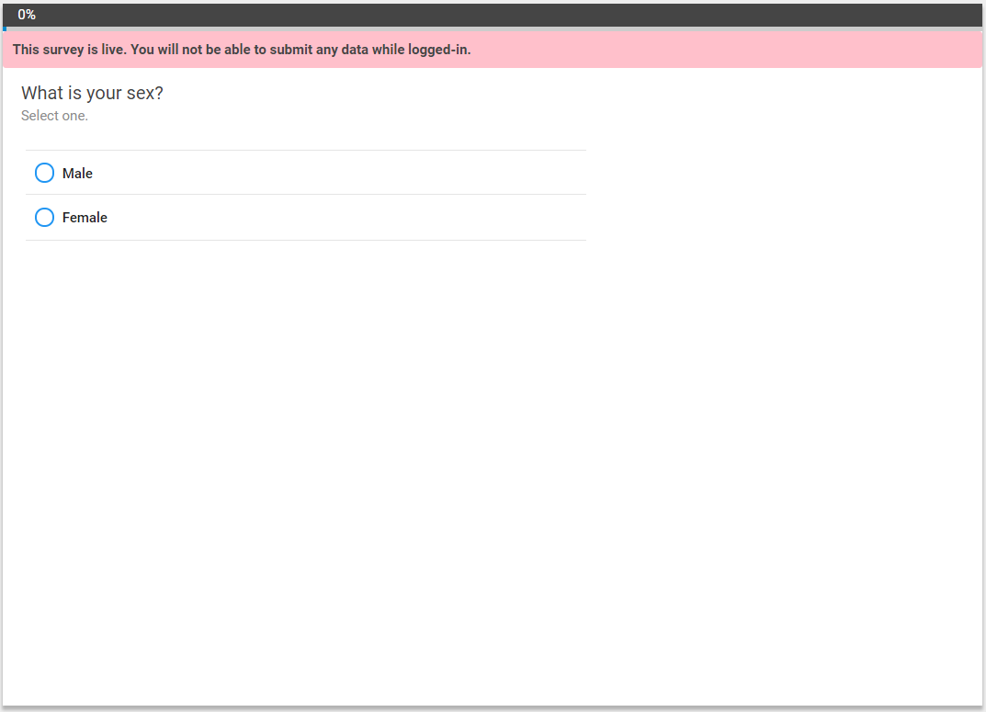

1.2 OE Text Field

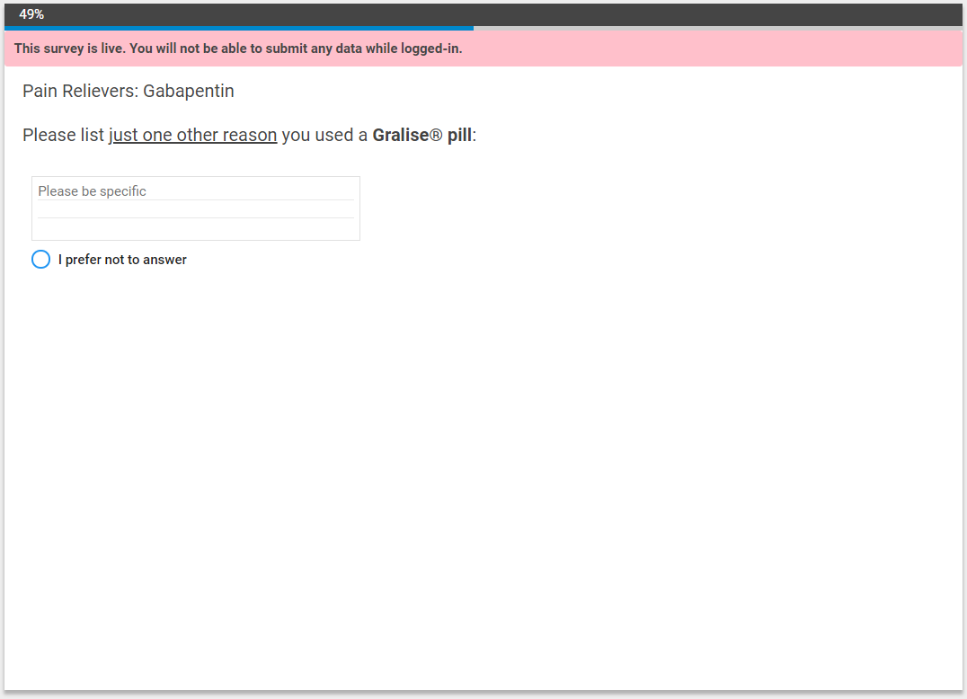

1.3 Checkboxes

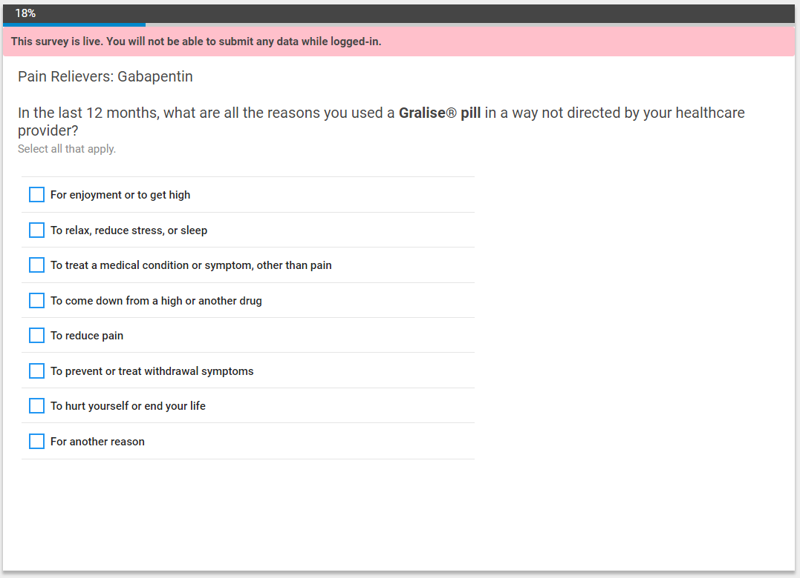

1.4 Lifetime Use & NMU

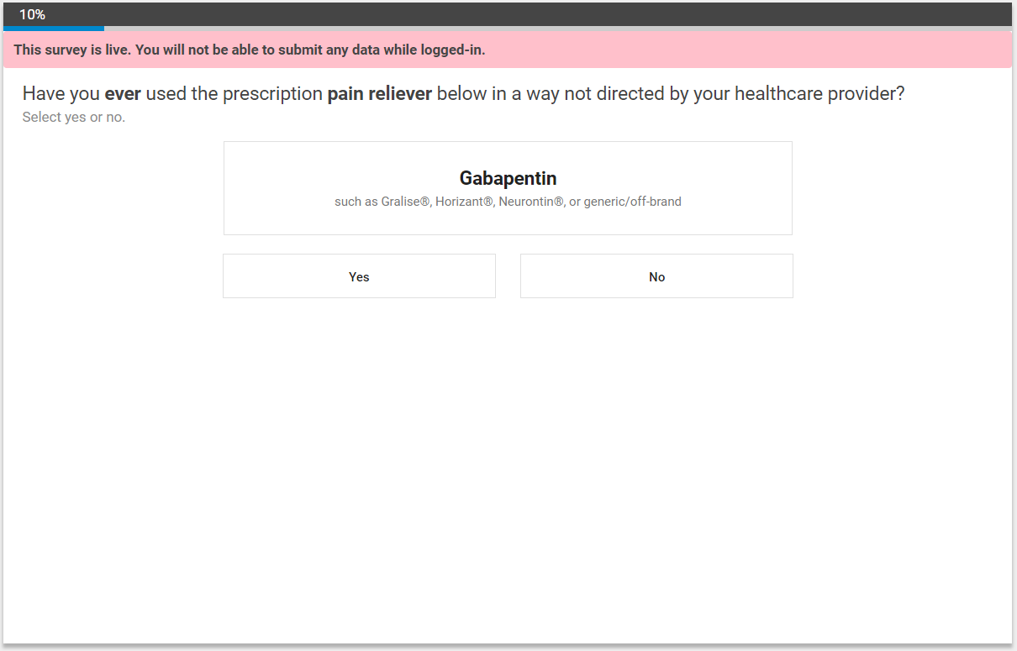

1.6 Product NMU

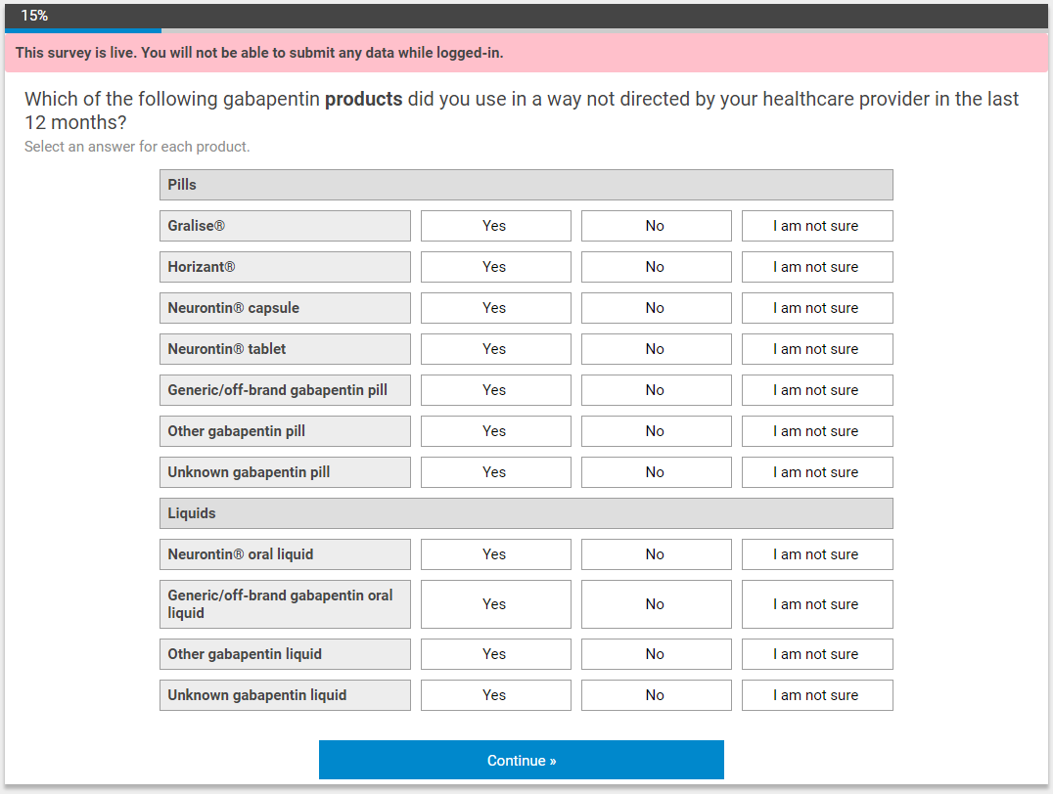

1.7 Scrolling Checkbox

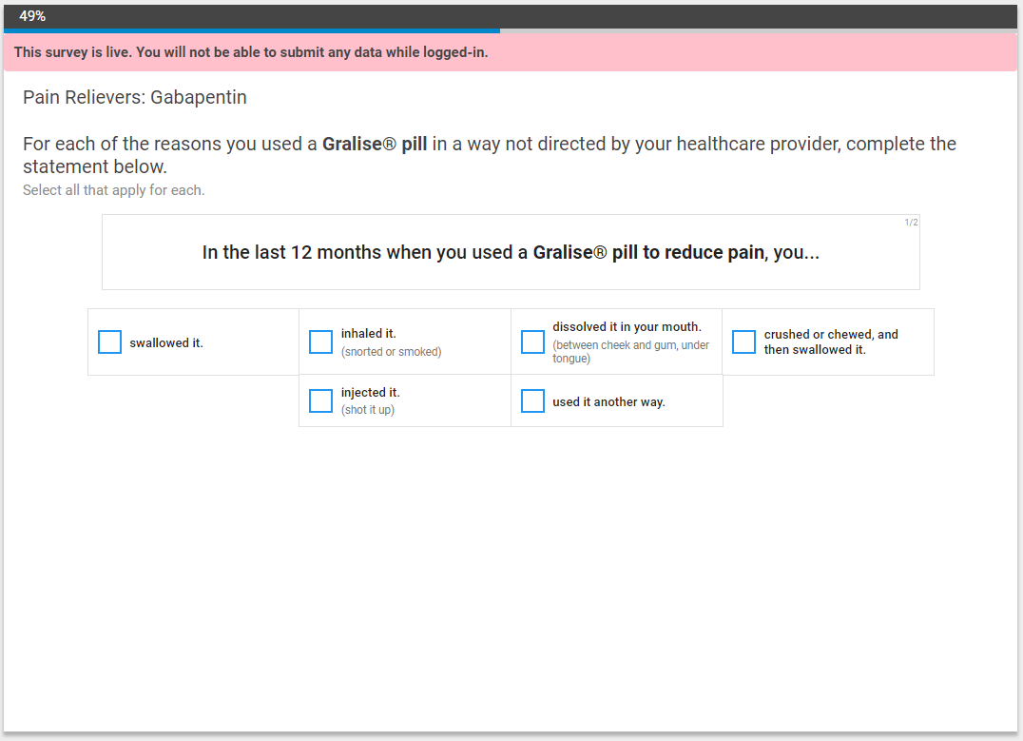

1.8 Single Select Drag & Drop

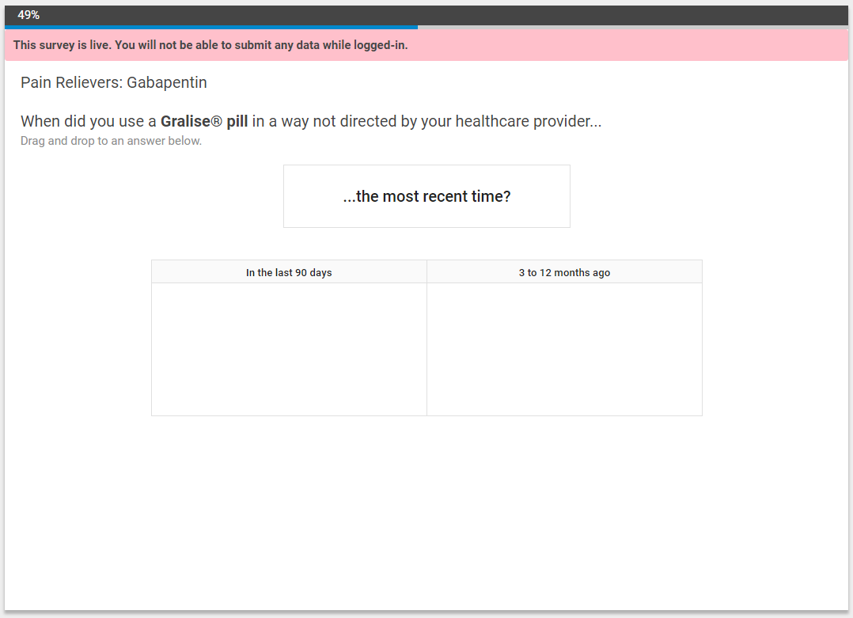

1.10 Single Slider

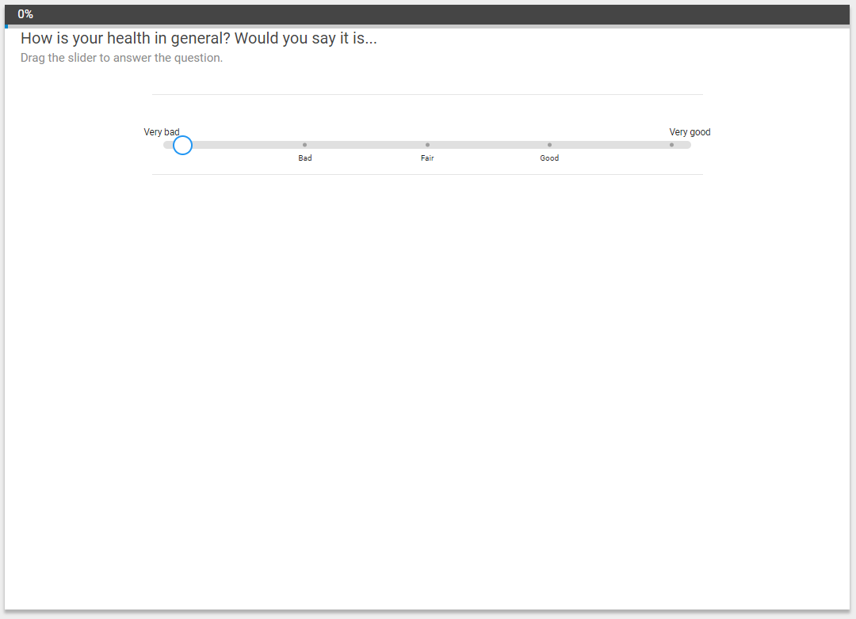

1.11 OE Numeric Field

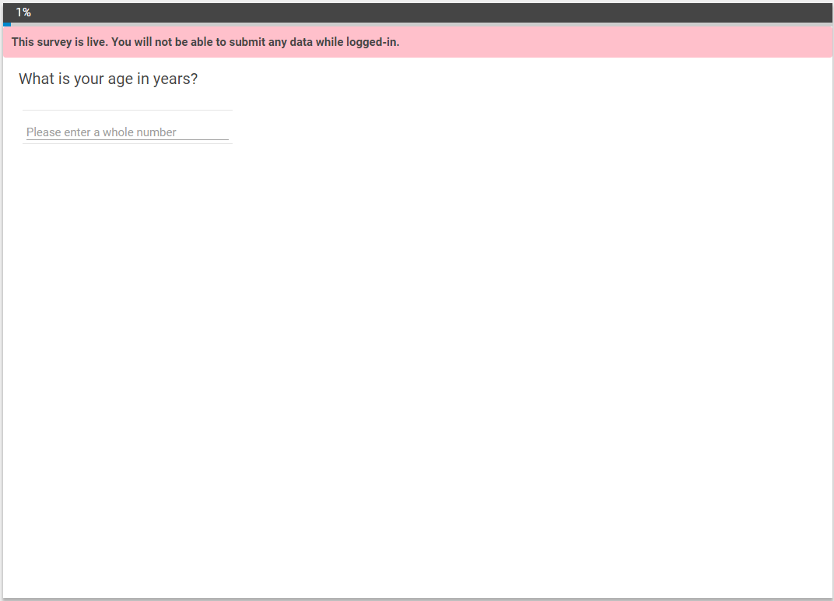

1.12 Dast-10

